


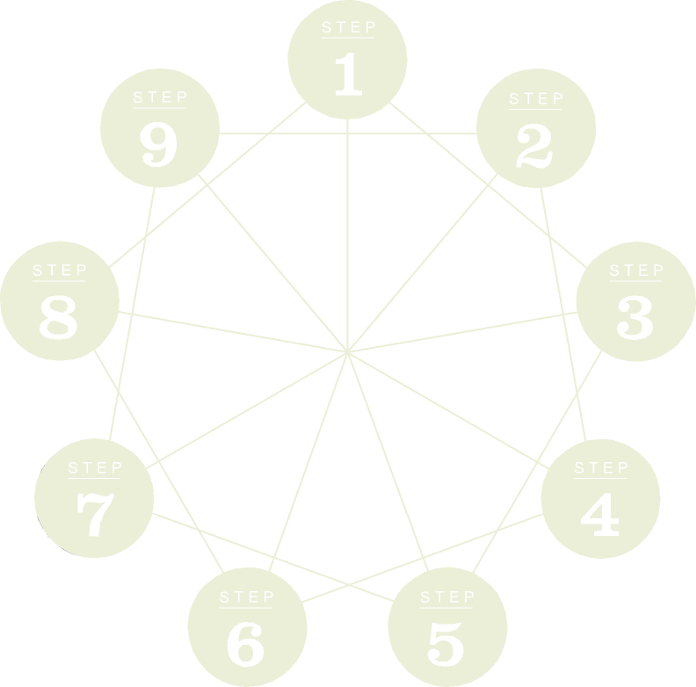

Transforming Your Relationship with Money
Financial Integrity

The Financial Integrity Program Guide

The Financial Integrity Program Guide
Version 1.4 (replacing and superceding all previous versions)
was created and published in 2009 by The New Road Map Foundation
Creative Commons Attribution Share-Alike 3.0 US License, some rights reserved.
The New Road Map Foundation is a 501(c)3 nonprofit organization that supports people in transforming their relationship with money and aligning their economic choices with their values. Tax deductible contributions to support this work can be mailed to:
PO Box 1363
Langley, WA, USA 98260
www.financialintegrity.org

This work is licensed under the Creative Commons Attribution-Share Alike 3.0 United States License. This means you are welcome to use, distribute, and make adaptations and derivative works, with the following restrictions and attribution added to any work you use or create:
This work is licensed under Creative Commons Attribution Share-Alike 3.0 US License. It is based on the Financial Integrity materials developed by the New Road Map Foundation, available for free at www.financialintegrity.org
The enclosed NRM's Financial Integrity material is based on the original seminars “Transforming Your Relationship with Money and Achieving Financial Independence,” produced by New Road Map Foundation and performed by Joe Dominguez from 1984-1986. The nine-step program in this curriculum was later also detailed in Your Money or Your Life (Penguin Books, 1992 & 1999) by Joe Dominguez and Vicki Robin. In no way does NRM here imply a grant of use to any material written under any title other than Financial Integrity, nor material that was previously published under private copyright with rights reserved.
Acknowledgements
These materials were developed out of the collective energy of so very many people, over so very many decades – too many to name them all. Still, we would like to acknowledge those who have been involved over the past three years since the call was made to take “the money work” into the new century …
Monica Wood not only edited this Program Guide, but has been the calm, centering force behind this work since meeting Joe Dominguez back in 1960.
The “Financial Integrity” project would not have happened at all, if not for the courageous and generous spirit of Vicki Robin.
The volunteers with the NRM Speakers Bureau and Financial Integrity Associates (FIA) were the inspiration for this project:
Dave Wampler was the incredibly patient cajoler, who insisted the work be reborn.
Alan Seid was the captain who steered the project through the shoals and Heather Johnson helped see through the occasional fog.
Ann Haebig, Fred Ecks, Michael Stradley and Jane Dwinell were the task masters, ensuring not only the integrity of this particular material, but its universality.
Monique Tilford, Kevin Cornwell, Penny Yunuba, Lu Bauer, Liesbeth Trappenburg, Cecilia Finnigan, Mike & Linda Lenich, Linda Farris, Jacque Blix, David Heitmiller, Suzanne Ballantyne, Joseph Beckenbach, Jane Zeender, Tom Calloway, and Pam & Jonathan Allen played important roles at crucial times over the course of the new incarnation, as well as in the old heyday.
Rhoda Walter and the rest of the original NRM “system sisters” were ever a reminder of how an inspired and inspiring team can work wonders.
Special thanks to instigators of the “aha” moment: Carolyn Hilles, and Aileen Krush who asked at just the right time, “Is there a curriculum for teaching the nine-step program?”
And of course the worker bees: Katharine Wismer, Cultivate Marketing, Giodarno Kearfott Design, and especially the indefatigable Anne M. Jess. (Because sometimes it’s okay to bring in the pros for help).
Extra special thanks to Rozie Hughes, Queen Bee (and Chief Bottle Washer), who was not only blessed with this vision of how to bring the FI work into the new century and into The Commons, but made it happen and saw it through.
Ask Yourself These Questions
Are you comfortable with the amount of money you have? Is it enough? | Yes | No
Are you spending as much time with family and friends as you would like? | Yes | No
Do you come home from your job feeling fulfilled? | Yes | No
Do you have time to participate in things you believe are worthwhile? | Yes | No
If you were laid off from your job, would you see it as a tragedy or an opportunity? | Yes | No
Do you have enough savings to support you through six months of normal living expenses? | Yes | No
When you think about your finances, do you feel peaceful and at ease? | Yes | No
If you were to die in the next few years, would you be comfortable with your legacy or contribution to your family, your community, the world? | Yes | No
Are all the aspects of your life – your job, your possessions, your relationships, your values – integrated? Do they fit together? | Yes | No
If you answered 'No' to even one of these questions, you are in the right place!
Table of Contents
Welcome! 6
Introduction 13
Step 1 How Much Money Has Come into Your Life? And What Do You Have to Show for It? 26
Step 2 Being in the Present: Tracking Your Life Energy 40
Step 3 Where Is It All Going? Monthly Tabulation 55
Step 4 Three Questions that Will Transform Your Life 66
Step 5 Making Your Life Energy Visibile: Your Wall Chart 76
Step 6 Respecting Your Life Energy: Minimizing Spending 83
Step 7 Respecting Your Life Energy: Maximizing Income 95
Step 8 Capital and the Crossover Point 107
Step 9 Securing Your Financial Independence 120
Congratulations! 129

Welcome!
You are about to begin an exciting journey of exploration, learning and personal change.
So many people find money – the lack of it, the worry about it, the time spent making it, or the guilt associated with having it – to be an obstacle to happiness. Money often becomes the cause (or excuse) for people not living their dreams or exploring what their life could really mean.
The Financial Integrity Program helps you eliminate those obstacles. It teaches you to use money as a tool to get the life you want. It coaches you to act with intelligence, integrity, and independence in relation to money and the economic pressures we all face.
This program WORKS because it includes down-to-earth fiscal practices, infused with a radical approach that will change your perspective on money. When applied whole-heartedly, it can transform not just your wallet but your life.
Joe Dominguez developed the program in the 1960’s, His education went from the slums of New York to the offices of Wall Street. Along the way he developed practical hands-on steps to integrate timeless financial wisdom into everyday life. Joe Dominguez “retired” at the age of 31, never again to take money for his labors. Together with Vicki Robin, Monica Wood, and a cohort of other volunteer-philanthropists, he founded the New Road Map Foundation in 1984, to more formally help spread the word about this effective, transformative approach to money. Joe died in 1997, but his program lives on.
Until now this program did not have an official name, though hundreds of thousands know about this nine-step program through the seminar and audio course “Transforming Your Relationship with Money” (by Joe Dominguez) and the bestselling book Your Money or Your Life (by Joe Dominguez and Vicki Robin). We named it “The Financial Integrity Program” because 30 years has shown that people have most valued the sense of INTEGRITY the program brings to their lives.
Ultimately, the program is simply a toolbox for you to build a healthy relationship with money that will bring you peace of mind. The only requirement for success on your part is diligence and honesty – and doing the steps.
So, welcome! And congratulations on starting a journey that will change your life!
New Road Map Foundation
Seattle, 2008

What Is Financial Integrity?
Some people define “integrity” as
- the quality or condition of being whole
- having substantial or enduring character
- congruity, alignment, integration
What comes to mind when you hear that a building has “structural integrity”? You might imagine the building to be safe, strong and secure – it will hold together well and serve the inhabitants for a long time, thus fulfilling its purpose.
Financial integrity is much the same – it implies strength, security and honesty when it comes to money. It means walking your talk, and it involves making wise choices to achieve purposeful, reliable and beneficial ends.
Here are a few comments from people who have worked with the Financial Integrity program:
“I got out of a great deal of consumer debt, tripled my retirement savings, and built an emergency fund. For the first time in my life, I know for sure that I am consistently living below my means and I'm prepared for unpredictable expenses.”
“It gave me a new way of looking at the relationship between time and money. I found I value time much more than money and I found out what "enough" was for me. Invaluable.”
“I stumbled across [the program] six years ago and found – miracle – all my feelings and ideas understood and shared… While doing the steps I found out that I was financially independent already but… it is not the end of the journey, it is the beginning. Now I know why people who win a large sum in a lottery very seldom remain wealthy. It’s because they have never learned [financial integrity.] I quit my paid job last year at the age of 40.”
“First (in 1992) – success meant being financially independent. Seemed totally impossible when we started out… our wall chart now shows independence around next spring (2008). Success is still evolving, but at the moment it means stronger relationships, more time, making more change for our definition of ‘better’, and more freedom. It also means that a possession will never again take precedence over the successes above. Our possessions only exist to serve the above.”

Financial Integrity Will Help You
The Financial Integrity (FI) Program is a method to help you create a healthy, empowering relationship with money, allowing you to get beyond money concerns and get on with LIFE. There are many positive outcomes from this program.
FI can help you:
- Reduce stress around money.
- Have more clarity about money.
- Feel more in control and empowered about money.
- Get out of debt faster than you thought possible.
- Live within your means and develop savings.
- Get to the point where you can choose the type of work you do.
- Reconnect with a greater meaning and purpose in your life.
- Have more time for the activities and people that are important to you.
- Experience more fulfillment in your life.

Which of these are relevant to you?

The Financial Integrity Program
The Financial Integrity (FI) program involves nine distinct hands-on practices. While we refer to them as the nine “steps”, they are not like steps in a ladder; they don’t lead you up to some mythical realm of riches where, once you arrive, you can let the ladder drop and forget how you got there! What they do accomplish is to integrate timeless financial wisdom into daily decisions and actions. These steps are actually skills and mindfulness practices that can serve you for the rest of your life.
These practices are a bit like parts of a DNA spiral – they are the building blocks of a contented life. They are interconnected and interdependent, each one important to the whole.
How you put them together is up to you. Even if you do only one of the steps, we guarantee you will get something out of it. But why stop with just one? Just as all the spokes of a wheel are important to moving forward smoothly, so it is with the steps. When you give equal weight to ALL the steps, in their appropriate order, you can go to amazing places very quickly. And when you discover how well they work, you will move through them over and over again.
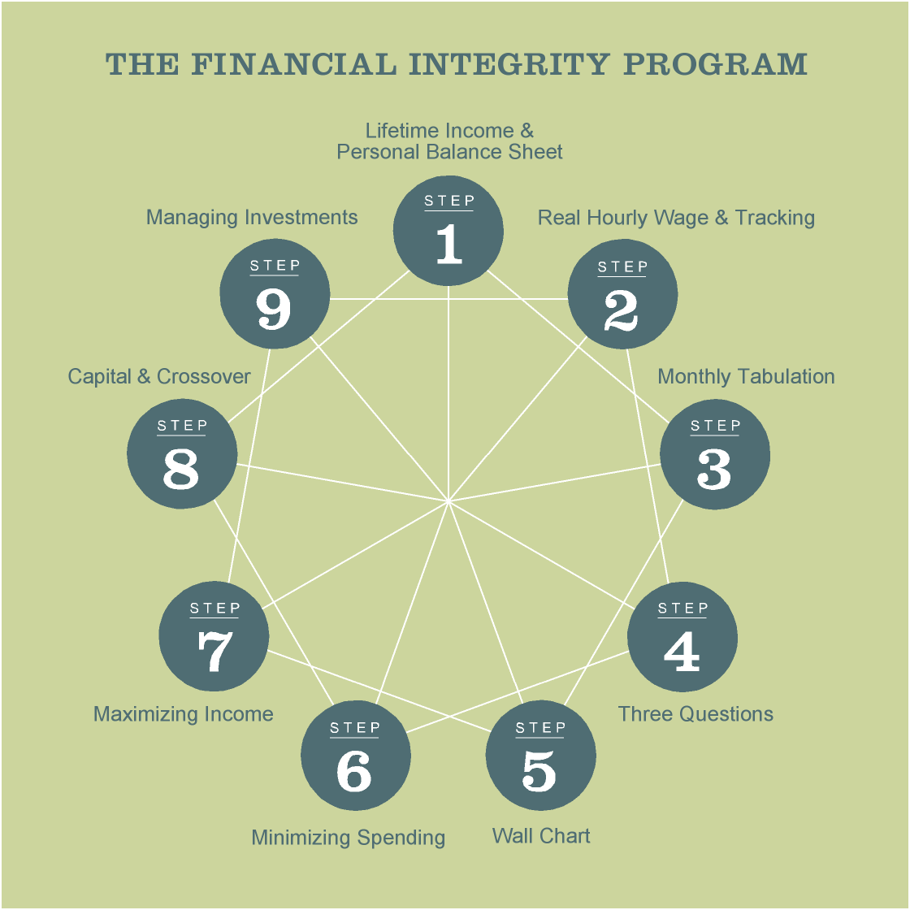

The Nine Steps – A Quick Overview
Step 1 | How much money has come into your life, and what do you have to show for it?  in order to move forward in a new way, it’s important to figure out how you got where you are. Calculate your lifetime incomeestimate and create a personal balance sheet.
Step 2 | Being in the present: Tracking your life energy.  Build an understanding of what this “money” stuff is worth in relation to YOUR life. Calculate your real hourly wage -- the current monetary value of your time and energy. Become aware of all your financial transactions and their real cost.
Step 3 | Where’s it all going: Monthly tabulation.  Observe your current habits and needs around money. Keep a monthly record of your spending patterns and how they affect your bottom line.
Step 4 | Three questions that will transform your life.  Create a foundation for making the changes you want to make. Evaluate your spending based on your own satisfaction, values and goals.
Step 5 | Make it visible: Your wall chart.  Look at your progress and the positive affects as you make changes.Track your progress monthly in order to stay motivated for long-term goals.
Step 6 | Respecting your life energy: Minimizing spending.  Naturally reduce expenses by applying a new approach to spending that reflects maximum fulfillment for your life as a whole.
Step 7 | Respecting your life energy: Maximizing income.  Naturally increase income, in alignment with your health and integrity, by recognizing your time as a precious, limited resource.
Step 8 | Capital and the cross-over point.  Set a goal – “enough and then some.” Invest your savings to receive income regardless of employment status, and estimate the time of financial independence.
Step 9 | Securing your financial independence.  Take personal responsibility for your future and become knowledgeable, sophisticated and adept about investment vehicles within your own self-defined criteria.

The Financial Integrity Program Guide Structure
Each Step of the Financial Integrity Program includes these components:
Overview A brief description of the purpose and objectives of the step.
Preparation Required materials and pre-step exercises.
Preview A quick preview of the step actions.
How It Works Concepts, actions and practices of the step.
Case Studies Throughout the program guide, we follow two people as they move through the steps. These two reflect some of the different situations people face as they work with this program, as well as the varied approaches people have taken in doing the steps. For real-life stories and tips, go to the FI web site, www.financialintegrity.org.
Review & Reflection The key points of the Step, and a chance to deepen your learning and integrate your experiences.
Tips for Success Follow-up advice and activities to strengthen your process.

Tips for Success
People who have been successful with this program suggest:
- Create a convenient place for your personal FI materials. For example, you could store your papers and worksheets in a 3-ring binder, or create a special directory/folder on your computer.
- Be open to new ideas.
- Pay attention to yourself when you feel resistance. Notice what those moments teach you about yourself.
- Customize the practices to fit your life, while keeping to the intent of each step.
- Be patient with yourself and others. Change can be harder than staying with the status quo.
- Keep a journal of your thoughts along the way. Watch how your responses and reactions to each step evolve, as you repeat the steps over time.
- Find community and other resources for support and camaraderie. Check out the resources found on the Financial Integrity web site www.financialintegrity.org.

Introduction
Transforming Your Relationship With Money

When we talk about having a “relationship with money,” we mean your general approach to your economic activities – how you earn money and how you spend it, save it or give it away – and the thoughts and feelings associated with those activities.
Many people don’t feel in control of their relationship with money, because either they don’t understand how it developed or they never even thought about other ways of relating to money. Your own approach may have made sense at one point, but now you are unsatisfied.
This program is about paying close attention to your usual approach to money, rethinking it, and then building a new relationship that truly fits your life. In this chapter, we’ll explore a typical relationship with money and begin taking a fresh look at the purpose of money.

The Nine Circles Exercise
Try this exercise.
Connect all nine circles with three straight lines, without lifting your pen or pencil off the paper. You can do this in your head or on this page.

If you find this exercise challenging, try thinking “outside the box.”
Still stumped? Check the end of this chapter for the solution.

Thinking Outside the Box
Thinking outside the box involves questioning the norms that we follow – how we usually operate. Do these norms really make sense? Do they really work for me?
We all make assumptions – which our culture, more often than not, supports. As with the nine-circles exercise:
- Sometimes we make assumptions by putting something there that isn’t really there – such as a box around the circles.
- Sometimes, we make assumptions by limiting our view and overlooking something that is right there in front of us – such as assuming the circles are dots without dimensions.

We do the same thing with money:
- Some people believe money, in and of itself, equals happiness, while others think money is evil. We make up ideas around money, just like we “see” a box around the circles.
- Some people think they’ll never have enough money. Such thoughts and beliefs limit our view so that we don’t see opportunities that are right in front of us.
So how do we start seeing things as they really are? For starters, by being willing to question your assumptions around money, as well as your culture’s messages about money, and investigating what is really true for YOU.

The Fulfillment Curve
Does money make us happy? Most of us never received any specific education about money. We humans learn at an early age by mimicking others. In this way we adopted certain beliefs around money when we were children – beliefs that may or may not serve us well. We need to examine those beliefs and assumptions in order to weed out what no longer is working.
We usually spend money trying to make our lives better or happier in some way. When we’re hungry we might spend money, perhaps on a piece of fruit, and feel good. We might spend even more money buying food for a holiday feast and feel even better.
If we want to chart this dynamic we might set up a graph like the following:
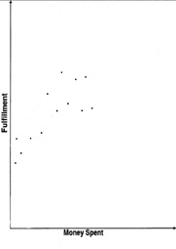
(Feast $50)
(Fruit $.50)
This is one way to represent the relationship between the amount of money we spend (horizontal axis) and the amount of satisfaction or fulfillment we feel as a result (vertical axis). When a line is drawn to represent the overall trend in how money spent relates to fulfillment, we call the diagram “the Fulfillment Curve”.
Let’s use this model to take a closer look at how a typical relationship with money develops.

Survival
When we were little babies, it didn’t take a lot to make us happy. We learned a particular way to gain satisfaction: when we were uncomfortable we cried, and something came to take care of us. We cried when we were hungry, and we were fed. Our needs were filled. Our minds recorded these experiences and remembered the message: Fulfillment comes from outside of us.
As we got older we had to start filling some of those needs for ourselves, and we learned to use money rather than crying to get what we needed. When we got out of school, we got a job to pay for food, clothes, and a place to sleep. We got satisfaction from taking care of ourselves, getting jobs to earn the money that paid for those necessities. We spent money and we were fed, warmed, and sheltered. And we learned: money = fulfillment.

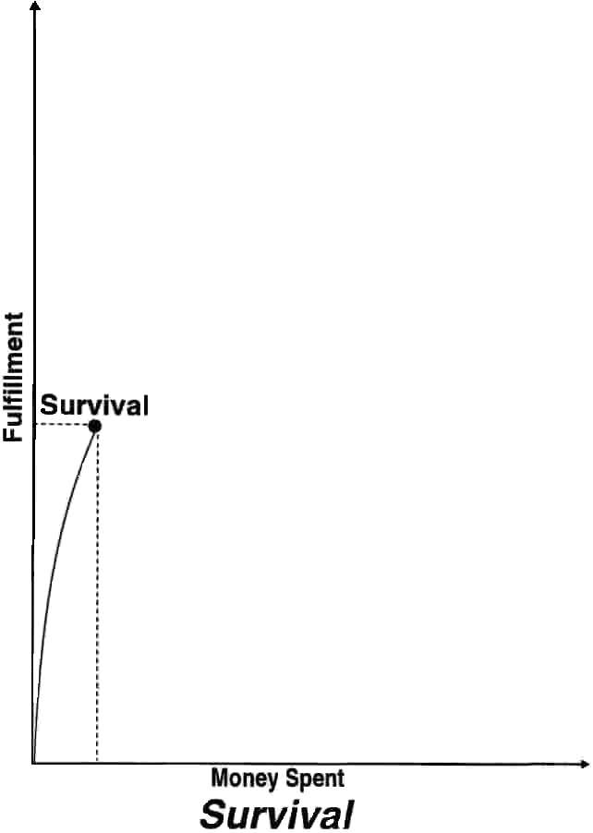

This diagram shows that, on the level of basic necessities, a little money can bring a LOT of satisfaction.

Comforts
When we go from buying necessities (things that keep us safe and healthy) to buying comforts (things that make life comfortable and nice), our belief in the positive relationship between money and fulfillment gets even stronger.
We have a coat to keep us warm, but for a little more money we can have a coat that is also fashionable, in the latest style. We’re able to feed ourselves, but for more money we can eat at a restaurant (where someone else does the dishes). More money spent, more fulfillment. We begin to take basic survival needs for granted, and our definition of success shifts. And the notion of more money = more fulfillment is further embedded.

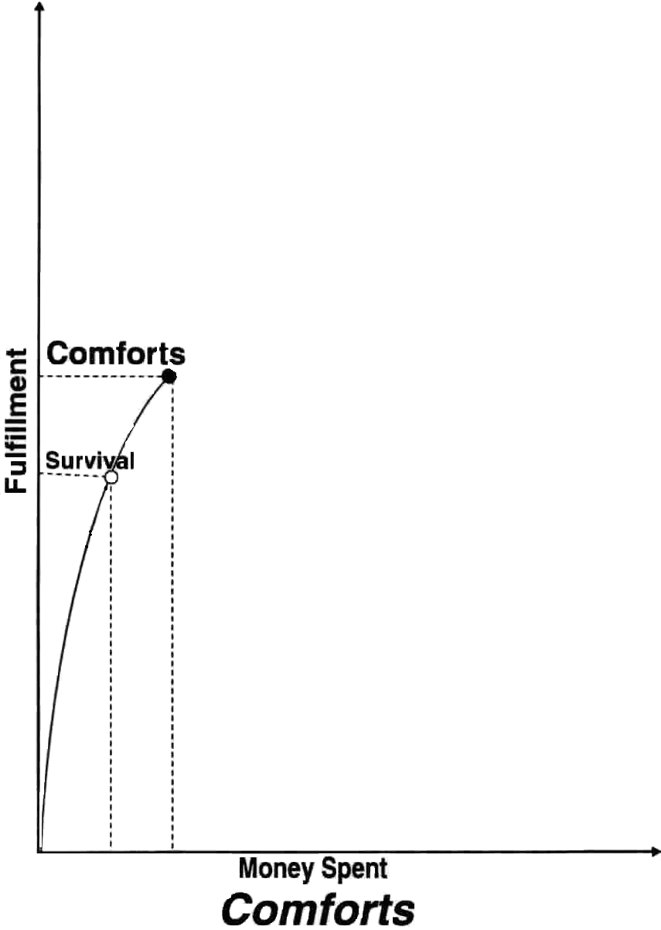
This diagram shows that the more money we spend for things that make life more comfortable, the more fulfillment we feel.
We have developed a belief around money, which is largely unconscious –– the more money we spend, the more happy and satisfied we’ll feel. More is better.

Luxuries
Eventually, anyone can spend beyond comforts to outright luxuries – and hardly register the change. For example, a car is a luxury that most people in the world never enjoy. But most of us who own cars think that we’d be happier if we just had a newer car – or even a second car. Or we’d be happier if we had a bigger house, or a vacation home, or a cruise to Hawai or ….. Such luxuries cost more than comforts and MUCH more than basic necessities, so we have to keep acquiring more money in order to buy them.
By now we firmly believe that money equals fulfillment, so we barely notice that it’s taking more and more money for smaller and smaller amounts of fulfillment – and the fulfillment doesn’t last. On we go with our life, acquiring and spending, hoping it will make us feel good, feel worthy, feel fulfilled. But the thrill is gone.
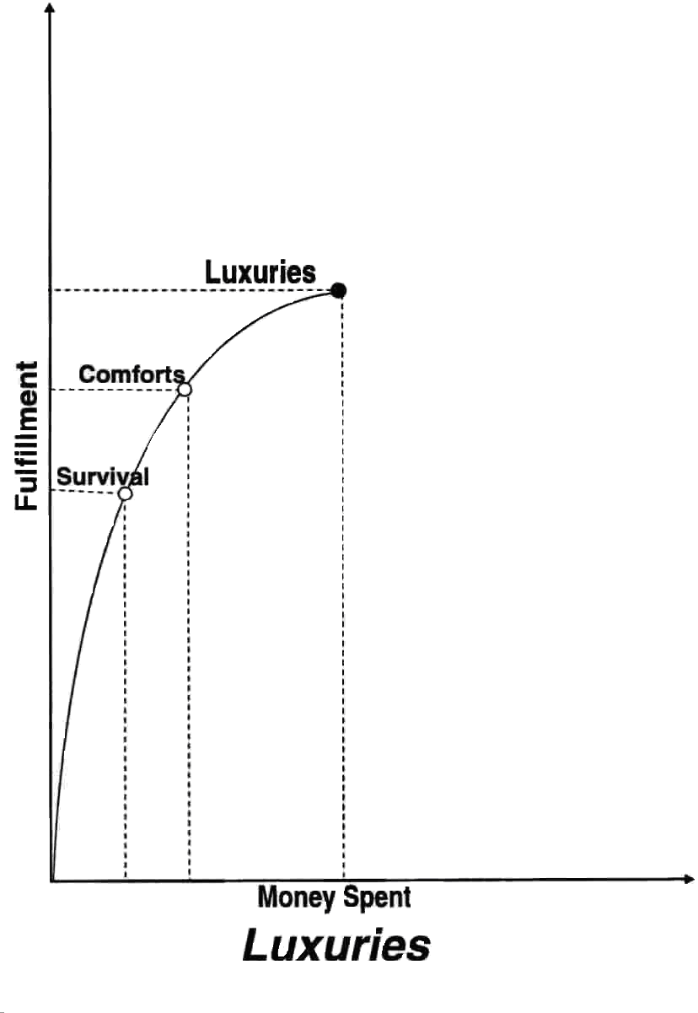
This diagram indicates that fulfillment is not nearly proportional to the amount of money spent on luxuries – the curve is starting to level out.

Clutter
One day we hit a fulfillment ceiling and it looks like more is not better after all – but we’re hooked. The formula “money = fulfillment” has not only stopped working but has started to work against us; our possessions have become burdens. Each new thing we buy costs us more time and energy: to learn how to use it, maintain it, accessorize it, store it, fix it, and pay interest on the payments for it. There’s more to lose (and for others to envy) so we spend more money on security and protection – resulting in the need to make MORE money! But spending that money doesn’t bring us the fulfillment it once did; it just brings a sense of burden or futility.
Everything after the peak of the Fulfillment Curve is excess. We call it clutter.

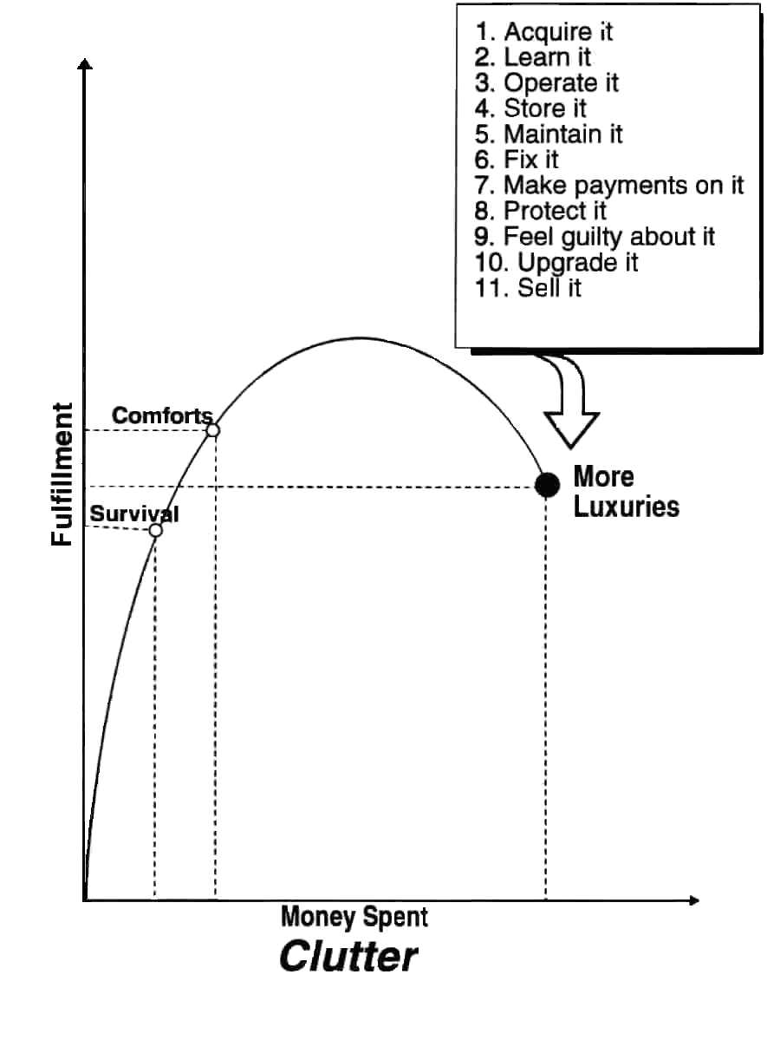
The formula stopped working; our possessions have become clutter; and from now on, it’s down hill all the way. Could the belief that money = fulfillment be wrong?

Recognizing Enough
Why doesn't “money = fulfillment” work any more? A dynamic in economics called “the law of diminishing returns” has to do with natural limits. Another way to think of natural limits is “ENOUGH-ness.”
Think of it in terms of a cake: the first bite is delicious, and the second and third. It tastes good, the sugar kicks in, you feel happy, and your stomach is full. But if you keep eating after you’re full, you get a bellyache; you’ve had too much, and happiness fades fast!
There's a very interesting place on our Fulfillment Curve – the peak. This point of maximum fulfillment is a key to happiness and a healthy relationship with money, and each of us must identify it for ourselves. We call that peak ENOUGH.
It’s not always easy to recognize “enough.” Cultural pressures around money and family and social norms can get in the way. Advertising tries to make sure that we always want more on the material level, that we always experience yearning and dissatisfaction with what we have, and that we think spending more money will solve our problems – spending more and more, until our lives are over or all our money is gone.

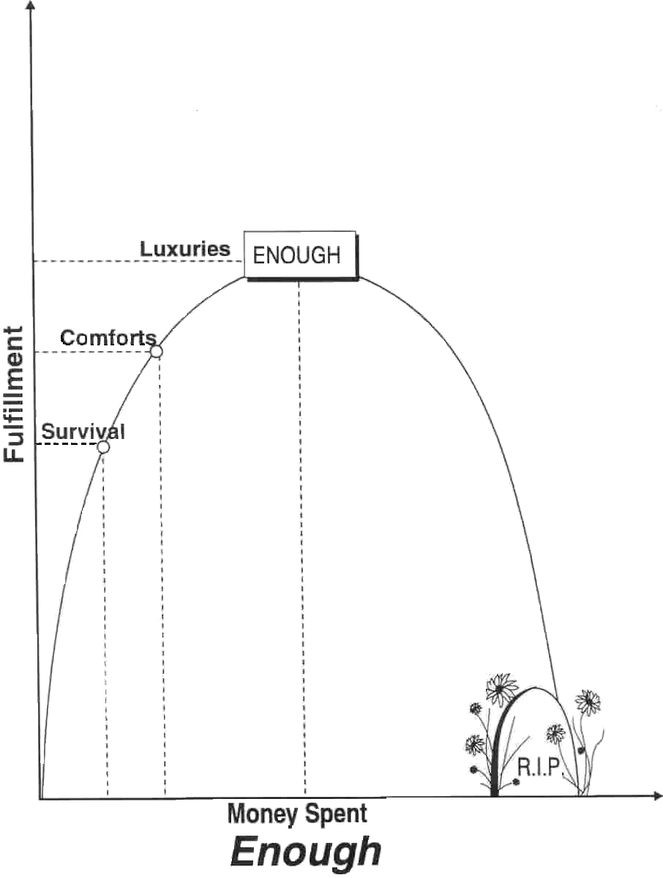

The Power of Enough
How do we know when we have ENOUGH? When we have everything we need, but nothing in excess. We have enough for our survival, for our comforts, and even for a few luxuries; we feel satisfied, and there's nothing in excess to burden us or complicate our lives. Enough is appreciating and enjoying what money has brought us but not buying anything that we don’t really want or need; feeling pleasantly “full” of money without that constant yearning for more.
Enough is place of power and freedom – a launching point for cultivating the kind of fulfillment that money can't buy. We can go from a relationship with money that revolves around fretting and consuming to one that is oriented around creating and giving.
That peak we strive for is a dynamic place. Maximum fulfillment comes from learning to recognize that feeling of “enough” and adjusting our actions accordingly.
It takes certain skills and qualities …
- to reach enough
- to recognize when you’ve reached enough
- to stay near that peak of the Fulfillment Curve, without falling back into deprivation or down into gluttony.
The next nine chapters will provide you with the tools you need to build those skills and create the conditions for maximum fulfillment.

Your Relationship with Money
Now that you’ve seen what a relationship with money can look like – take a few moments to think about your relationship with money.

How would you rate your current relationship with money? (Check one)
- Very comfortable (solid, consistent, dependable, free from worry, little or no time devoted to acquiring and managing it)
- Comfortable (pleasant, easy, few worries, an acceptable amount of time devoted to acquiring and managing it)
- Neutral (normal, an average amount of time devoted to acquiring and managing it)
- Bad (clouded with persistent feelings of fear, worry, deprivation, hopelessness; no matter how much time devoted to acquiring and managing it, it’s never enough)

What are your current feelings about money? (Fill in the blanks)
Fill in the blanks using Items you spend money on (such as clothing, books, gifts) and Feelings (such as guilty, virtuous, angry, joyful, worried, and so on). For example: When I spend money on new shoes, I feel happy. When I spend money on convenience foods I feel guilty.
- When I spend money on _______________I feel ______________.
- When I spend money on _______________I feel ______________.
- When I spend money on _______________I feel ______________.
- When I spend money on _______________I feel ______________.
- When I spend money on _______________I feel ______________.
- When I spend money on _______________I feel ______________.

Review and Reflection
- It’s useful to evaluate our beliefs around money to see if they really serve us. To get a fresh perspective and create room for change, it’s important to “think outside the box” of custom and habit.
- Does your relationship with money help you feel happy, or does it seem to get in the way?
- “Enough” is a free place, full of appreciation for what money brings into our lives. What would “enough” feel like for you? What would be different?
- What decisions have you made – consciously or unconsciously – that created your current financial situation? Would you make the same choices again?

Tips for Success
- Spend some time writing down your earliest impressions about money. How do they affect your approach to money now?
- Look at some of your possessions. Notice how you felt about them when they were new. You might chart your reactions, based on fulfillment and money spent. Think about them now – are they necessities, comforts, luxuries or clutter? What did you think at the time you bought them?


The Nine Circles Exercise – Solution

Step 1
How Much Money Has Come into Your Life?
And What Do You Have to Show for It?
Step 1:
Lifetime Income &
Personal Balance Sheet

Step 1 Overview
This step is about taking a clear, honest look at your current financial situation and how you got there. This is an important step in orienting yourself toward positive change. In this chapter you’ll review your earning history and get an idea of how much money has come into your life. Then you’ll then take a look at how you’ve managed it, reviewing what you own and what you owe (assets and liabilities) in order to get an accurate picture of your finances today. Getting clear with the past prepares you to come into the present.
In Step 1 you will create two tools for your journey to “enough”:
- Your Lifetime Income Estimate
- Your Personal Balance Sheet

Step 1 Preparation
Step 1 is the most involved step in terms of gathering data. The more accurate you are in doing this, the more clarity you will get about your current situation. To get the most out of Step 1 it will be helpful to:
- Locate your Social Security Administration (SSA) “Statement of Earnings.” The SSA sends out these statements annually. If you don’t have a recent copy you can visit your local SSA office or go to their website to request one.Your SSA statement lists your reported income since you started working.
- Recall or gather records of money received that is not reflected in your SSA Statement.
- Find out the current balances on your bank accounts, loans and other debts. (Check your statements, call your bank).
- Get an idea of the current value of your house, car and other valuable possessions.
- Refer to the Financial Integrity web site for additional resources (www.financialintegrity.org).

Step 1 Preview

Part A. Estimate Your Lifetime Income

Lifetime Income Worksheet
Financial Sources | Amount
Taxed income (SSA report) | $
Untaxed jobs | $
Selling stuff (cars, CD’s) | $
Allowance/spending money | $
Gifts | $
Interest on savings | $
Total Lifetime Income (Estimate) | $

Part B. Create a Personal Balance Sheet

Personal Balance Sheet
OWN |  | OWE
Liquid Assets | (+) Cash Value | Liabilities | (-) Cash Value
Cash on hand | $ | Car loan | $
Bank Accounts | $ | School loans | $
Investments | $ | Mortgage | $
 |  | Credit Cards | $
Hard Assets | (+) Cash Value | Personal Loan | $
House | $
Vehicles | $
Personal items | $
Total Own | $_________ | Total Owe | $_________
Personal Financial Net Worth:
Assets – Liabilities = $_______

Step 1 How It Works

Part A: Determine Your Lifetime Income
Why explore your income history?
- This process is empowering; it will remind you that you can bring money into your life.
- Your income history, along with your Personal Balance Sheet in Part B, will help you realize just how you’ve stewarded that money.
- If you have made very little money over the years, it will help you recognize how resourceful you’ve been in living on less.

How much money have you earned in your lifetime? How much money other than earnings has come into your life?
Lifetime income includes both reported and non-reported income. You can find out your reported income from the government. US citizens can get that information from the Social Security Administration.
Non-reported income is money, other than taxed wages, that has come into your life. Much of that is undocumented so you will have to remember and estimate. You can go back through your memory year by year, ask family members, and look at your bank statements for deposits.

Lifetime Income Worksheet
Financial Sources | Amount
 | $
 | $
 | $
 | $
 | $
 | $
 | $
 | $
Total Lifetime Income (Estimate) | $

Case Study: Jamie – Lifetime Income Worksheet
Jamie is 28 years old, single, living in an apartment, a house painter by trade, and has been working full-time for ten years.

Jamie’s Lifetime Income
Financial Sources | Amount
Reported Income (SSA report) | $300,560
Savings bonds from Uncle Joe | $20,000
Work for Uncle Joe (unreported) | $1,500
Sold my piano | $700
Sold my old car | $1,200
Birthday gifts over the years | $400
Total Lifetime Income | $324,360

Case Study: Chris – Lifetime Income Worksheet
Chris is 40 years old, married with two children, and owns a house and a vacation cabin. Chris has been working for 15 years as a hospital administrator. Chris spent six years as a full-time student. For two of those years, when Chris’ spouse Jessie was carrying all the financial responsibilities, Chris decided to record an estimate of value received, based on the estimated value of half the household expenses at that time.

Chris’ Lifetime Income
Financial Sources | Amount
Reported Income (SSA report) | $1,050,861
Tutoring in college (unreported) | $1,200
Inheritance & scholarships | $20,000
Allowance in high school ($25/week) | $5,200
Jessie covered expenses for 2 years  (est. of ½ the household bills) | $20,000
Net from sale of first home | $20,000
Interest income on savings (estimate!) | $1,560
Total Lifetime Income | $1,118,821

Part B. Create a Personal Balance Sheet
To create a new map to your future you need a starting point – an awareness of where you are, financially, right now. Your Personal Balance Sheet will serve as the “You Are Here” spot, as you chart a course into the future.
A balance sheet of assets and liabilities is a fundamental business practice. Treating yourself as a business will help you get an accurate, objective view of your current financial situation.
A Personal Balance Sheet is a snapshot of a moment in time; it is based on things that change regularly, like bank account and loan balances. If you have easy access to your balances, you can pick today’s date for your “snapshot.” Otherwise, pick a date in the near past for which you have all your records in hand.

Personal Balance Sheet
OWN |  | OWE
Liquid Assets | (+) Cash Value | Liabilities | (-) Cash Value
 | $ |  | $
 | $ |  | $
 | $ |  | $
 |  |  | $
Hard Assets | (+) Cash Value |  | $
 | $
 | $
 | $
Total Own | $_________ | Total Owe | $_________
Personal Financial Net Worth:
Assets – Liabilities = $_______

Identify and Record Your Assets
Your assets – the money and things you have accumulated over the years – are an important part of your financial picture.
Of course, you are more than just the things you own. You are a person with skills, talents and education. You have personal relationships, social connections and business networks. We call these intangible assets – those valued aspects of yourself that cannot possibly be assigned a monetary value. As these intangibles come to mind, you might want to keep a separate list of them as a reminder of your non-material assets. These things will be useful to remember when we get to Steps 6 and 7.
For now, we will focus on your financial assets – things with a specific cash value or things you could convert to cash if necessary. Financial assets can be broken up into two categories. We’ll call them “money” (liquid assets) and “stuff” (hard assets).

Your Liquid Assets – “Money”
Liquid Assets are cash and those items you could easily convert to “cash in hand” if needed. Use values from the beginning of the month.
Liquid assets include:
- Cash on hand
- Bank accounts: checking, savings, money market, certificates of deposit
- Savings bonds

Case Study: Jamie’s Liquid Assets

Liquid Assets | (+) Cash Value
Pocket cash | $52.37
Checking account | $1,200.00
Savings account | $6,750.00
Savings bonds | $20,000.00
Security deposit (apartment) | $500.00
Total Liquid | $28,502.37

Case Study: Chris’ Liquid Assets
Chris is married and shares assets with a spouse. For the purposes of this exercise, Chris has decided to record half of each asset shared by the household, since Chris lives in a “community property” state that assumes spouses share equally.

Liquid Assets | (+) Cash Value
Cash on hand | $71
Checking account | $7,800
Money Markey account | $25,000
Total Liquid | $32,871
Chris’ share (½) Liquid | $16,436

Your Hard Assets – “Stuff”
You have assets that are physical in nature, sometimes called “hard assets.” These are items you own and use, which you’re not as likely to turn into cash. They include such things as furniture, vehicles and jewelry.
Yes, this could take a while, but there are many benefits to documenting your financial situation besides just having the clarity of an accurate balance sheet – such as:
- You can update your insurance, documenting what you own so you can get full value in case you have to make a claim.
- You know how much money you could obtain if you need extra cash.
- You know how much you are leaving to your family in a case of untimely death, so they won’t have to figure out your estate in their bereavement.
One way to start listing your hard assets is to begin with the biggest, most valuable items you own, and then work your way down through less valuable items as you inventory your possessions. But keep in mind that all those little items (like tools or clothes) can add up. Check online and local resources for ideas on pricing your possessions. Estimate a realistic value, which probably is not the retail price of the same item brand-new.
When deciding how detailed to get, remember the purpose of this step: figuring out what you have to show for the money you’ve received!

Case Study: Jamie’s List of ”Stuff”

Hard Assets | (+) Cash Value
Truck | 15,000.00
Furniture | 970.00
Music equipment/instruments | 3,900.00
Tools | 750.00
Bike | 1,000.00
Clothes, coats | 250.00
Books/CDs | 920.00
Other items | 500.00
Total Hard Assets | $ 23,290

Case Study: Chris’ List of ”Stuff”
Chris did an inventory and estimated real-market value based on some research online:
Houses | Home | $325,000 |  | Furniture | 2 couches and 3 chairs,  coffee table, lamps,  end tables, book cases | $5,000
 | Cabin | $75,000 |  |  | 2 queen beds, 2 twins,  1 king bed | $1,000
 | Subtotal | $400,000 |  |  | 4 bureaus, 8 night stands | $360
 |  |  |  |  | Lamps | $100
Vehicles | Cars | $45,000 |  |  | Subtotal | $6,460
 | Motor boat | $20,000
 | Trailer | $3,000 |  | Tools & Appliances | Kitchen appliances | $500
 | Subtotal | $68,000 |  |  | Power tools | $300
 |  |  |  |  | Laundry appliances | $200
Antiques | Round table & chairs | $400 |  |  | Subtotal | $1,000
 | Hutch/armoire | $500
 | China/Silver | $400 |  | Game room | Pool table | $600
 | Oriental rugs | $1,200 |  |  | Stereo | $400
 | Subtotal | $2,500 |  |  | TV and equip | $2,400
 |  |  |  |  | Subtotal | $3,400
Jewelry/Clothes | necklaces | $1,000
 | rings, jewelry | $1,000 |  | Sports Equipment | All-terrain vehicles | $200
 | leather jackets | $1,500 |  |  | Skis, ski equipment | $300
 | Subtotal | $3,500 |  |  | Subtotal | $500
.
Hard Assets | (+) Cash Value
Houses | 400,000
Vehicles | 68,000
Antiques, Jewelry,Clothes | 6,000
Furniture | 6,460
Tools, Appliances | 1,000
Game room, sports equipment | 3,900
Total Hard $485, 360 – Chris’ share (½) | $242,680

Identify and Record Your Liabilities
A financial liability is a debt, an amount you owe to another person, business or institution (such as, a bank). This includes mortgages and personal loans, credit-card balances, school loans, car loans and other debts. Calculate your total liabilities by adding up what you owed on the same date that you calculated your liquid asset balance.
Case Study: Jamie’s Liabilities
Jamie’s finances are simple on the liabilities side: the only debt is $5000 for the balance of the truck loan.
Case Study: Chris’ Liabilities
OWE
Liabilities – Long-term Debt | (-) Value
College loan balance | 105,000
Mortgage balance (house) | 295,979
Mortgage balance (lake cabin) | 50,000
Total $455,000 –  Chris’ share (½) | 227,500
Liabilities – Short-term Debt | (-) Value
Car loan balance | 40,000
Visa Cards | 8,752
Mastercard | 9,800
Personal loan from Dad | 4,000
Total $62,552 –  Chris’ share (½) | 31,276
While all debt is simply money you owe, some people, like Chris, make a distinction between long-term debt that was used to buy assets that may increase in value (like houses or education) versus short-term or revolving debt (like credit cards, or debt for things like cars that may lose value before you are even done paying them off).
This distinction can help you prioritize what debt to pay off first, but it is not necessary for Step 1.

Calculate Your Net Worth
A “balance sheet” is a worksheet that compares what you owe with what you own to come up with a figure called “net worth” – a statement of your current financial situation.
To create a balance sheet, add up all your assets on the left side of a page, add all your liabilities on the right side, and then subtract your liabilities from your assets. This is your net worth – what you have to show for your lifetime income.
Case Study: Jamie’s Balance Sheet
Jamie’s Personal Balance Sheet
OWN |  | OWE
Liquid Assets | (+) Cash Value | Liabilities | (-) Cash Value
Pocket cash | $52.37 | Truck loan | $ 5000.00
Checking account | $1,200.00
Savings account | $6,750.00
Savings bonds | $20,000.00
Security deposit (apartment) | $500.00
Total Liquid | $28,502.37
Hard Assets | (+) Cash Value
Truck | 15,000.00
Furniture | 970.00
Music equipment/instruments | 3,900.00
Tools | 750.00
Bike | 1,000.00
Clothes, coats | 250.00
Books/CDs | 920.00
Other items | 500.00
Total Hard | $ 23,290.00
Total Own | $51,792.37 | Total Owe | $ 5000.00
Personal Financial Net Worth:
Assets – Liabilities = $46,792.37

Case Study: Chris’ Personal Balance Sheet
Chris’ Personal Balance Sheet
OWN |  | OWE
Liquid Assets | (+) Value | Liabilities – Long-term Debt | (-) Value
Cash on hand | $71 | College loan balance | 105,000
Checking account | $7,800 | Mortgage balance (house) | 295,979
Money Markey account | $25,000 | Mortgage balance (lake cabin) | 50,000
Total Liquid $32,871-  Chris’ share (½) Liquid | $16,436 | Total $450,979 –  Chris’ share (½) | 225,490
Hard Assets | (+)Value | Liabilities – Short-term Debt | (-) Value
Houses | 400,000 | Car loan balance | 40,000
Vehicles | 68,000 | Visa Cards | 8,752
Antiques, Jewelry,Clothes | 6,000 | Mastercard | 9,800
Furniture | 6,460 | Personal loan from Dad | 4,000
Tools, Appliances | 1,100 | Total $62,552 –  Chris’ share (½) | 31,276
Game room, sports equipment | 3,900
Total Hard $485, 360 –  Chris’ share (½) | $242,680
Total Own | $259,066 | Total Owe | $256,766
Personal Financial Net Worth:
Assets – Liabilities = $2,300

Emotional Impact
Step 1 can result in some “Aha!” moments of pride – or dismay! (Notice, for example, Chris’ low financial net worth relative to an impressive lifetime income).
- There is a full range of feelings that could come up in doing these steps. Whatever comes up for you is OK. This is about exploration. You’re not here to judge the past – just to see and accept it so you can move on.
- Some people even find they have a negative net worth. That’s when it‘s good to remember your lifetime income figure and reflect on how your automatic assumptions about money may have led you to this situation – and how a different approach going forward might create dramatic change in the future. The remaining eight steps will help you chart a new course.
SEE and ACCEPT the current reality.
UNDERSTAND the effect of the choices you’ve made.
TAKE RESPONSIBILITY for creating a fulfilling future!

Step 1 Review and Reflection
- Your Lifetime Income Estimate shows how much money has flowed into your life. Your Personal Balance Sheet indicates how much of that value you've retained – your “net worth.”
- A snapshot of your current financial reality helps you objectively assess your situation. This is an important reality check in setting a course for your future.
- Debts – even those associated with assets – decrease your net worth.
- You have many intangible assets, not shown in your financial net worth.
- What was your reaction to the Life Income activity? Did anything surprise you?
- How did it feel to learn how much money you've earned, and then to look at your net worth? What conclusions did you reach?
- What decisions have you made – consciously or unconsciously – that created your current financial situation? Would you make the same choices again?

Step 1 Tips for Success
- Update your Balance Sheet at least every year (some people do it monthly) – it's what successful businesses do to make sure they're on the right track, and your success is no less important.
- Keep a journal of your thoughts along the way and outline reasonable, incremental goals for the future.
- Remember that shame and blame don't accomplish anything but bad feelings. Keep your focus on walking into the future with a positive attitude.
- Make a list of your intangible assets and reflect on how you can use them to add to your quality of life.

Step 2
Being in the Present:
Tracking Your Life Energy
Step 2:
Real Hourly Wage
& Tracking

Step 2 Overview
In Step 1 you calculated how much money you’ve earned in your life, looked at how you’ve stewarded that money and created a Personal Balance Sheet. Getting clear with your past has prepared you to come into the present – where you will look at the specifics of money in your daily life. In this chapter you’ll start to take a closer look at the way money moves in and out of your life, day in and day out. You will also take a look at what money is and develop a reality-based definition of money that helps you see what it really means to YOUR life.
After completing this chapter you will be able to:
- Calculate your REAL hourly wage (RHW).
- Translate dollars spent into a meaningful measure: the time it took you to earn those dollars. We call this your “life energy.”
- Create a method for recording your daily money transactions. We call it “tracking your life energy.”

Step 2 Preparation
- Make a list of time expenses (hours spent commuting, making brown-bag lunches, shopping for clothes, non-paid overtime, and other) that are associated with your job.
- Make a list of things you have to pay for out of your pocket in order to maintain your job (work clothes, commuting costs, child-care, lunches, and so on).
- Before you continue, consider these questions:
What is your definition of “money”? What is the first thought that comes to mind?
Look at your “lifetime earnings” work in Step 1 and ascertain how much of that money came from paid employment as opposed to other income streams?

Step 2 Preview

Part A. Calculate Your Real Hourly Wage
An accurate, reality-based and useful definition of money is based on how much every dollar actually costs you in terms of the time needed to earn it. Once you know your real hourly wage, you will know how much “life energy” you are exchanging for each dollar you spend.

Real Hourly Wage (RHW) = Adjusted income ÷ Adjusted job hours
“Adjusted Income” is:
wages/salary plus value of job benefits received
minus the expenses you have because you work (gas or transit fares, income taxes, work clothes, and others)
“Adjusted job hours” is:
actual amount of time spent “on the job”
plus the time you spend on activities necessary to maintain the job (the hours spent commuting to work, shopping for clothes for the job, doing background research at home, and so on)

Establish the real value of your dollars
one dollar = ______ minutes of your Life Energy

Part B. Track the Daily Flow of Money in Your Life
Keep track of every cent that flows into or out of your life, every day.
EVERY cent, EVERY day.

Money: What is it?
Money buys happiness!
Money makes me feel loved.
I’ve got money!
I’m powerful!

Defining Money: We Need a Definition of Money that Is Useful
Some meanings often given to money:
  - Money is security.
  - Money is dirty.
  - Money is power.
  - Money is a necessary evil.
  - Money is a tool of political repression.
  - Money is happiness.
People project their own emotional meanings onto money. These might include happiness, status, self-esteem, acceptance, respect, exploitation, love, freedom, and so on. We may not actually define money by the meanings we attach to it, but we ACT as if money were these things.

What Does Money Mean to You?
What are your first memories around money? What were you taught about it? What did money mean to you growing up – and now? Do you feel differently about money having completed the exercises in Step 1?
Before continuing, take a few moments to jot down some of your own thoughts about what money means to you:

Means of Exchange?
Classic economic theory tells us that money is a means of exchange. But this is true only within a society that shares that agreement. If you were to be in the desert with a hunter-gatherer culture, your money would have no exchange value.
We need to find a definition that is not only consistently true but is also real in our lives – that has personal and useful relevance in our lives. Just WHAT is the nature of the exchange we are making?
In this program we define money as something for which you exchange your life energy – the hours of your life.
Consider these ideas:
- We spend our life energy in hours on the job in exchange for money. Anyone with a salaried or hourly job (like Jamie and Chris) fits this description.
~ or ~
- We support someone else (who earns money) with our life energy, thereby allowing money to come into our life. (Chris’ spouse works part-time in order to watch the kids after school, while Chris “trades” for this time by carrying more of the family expenses).
~ or ~
- We spend our life energy managing our investments, in exchange for increased dividends or value. Anyone who manages a portfolio or real-estate property fits this description. (Both Jamie and Chris do this eventually, as we’ll see in Steps 8 and 9).
No matter how we acquire money, we spend some amount of time (life energy) to get it. The amount of life energy may not be the same in every instance, but it is universally true that life energy was traded for money.
Money = something we trade our life energy for
Every dollar you spend is equal to the amount of your life energy it took to get it.
An hour of your life is precious, because it’s limited. Once it’s gone you can never get it back. When you spend money you are spending your life energy, your time.
So the question is:
How much of your life are you trading for your money?

Step 2 How It Works

Part A: Calculate Your Real Hourly Wage
The point of spending your time making money is… to make money! Get realistic – how much money are you REALLY receiving for the time you’re putting in? The fact is, employment costs you – and sometimes it’s a lot more than just your time. So it’s important to know your REAL hourly wage – not what your paycheck says, not the one you think you’re worth….
You want to know the real return on your investment of time.
Once you know that, you can figure out just how much life energy you’re exchanging for every dollar you make (and spend).
There are some hidden and not-so-hidden tangible costs and benefits of working. On the next few pages, we will explore those in more depth.

Work-Related Benefits
Jobs often offer benefits to employees. As part of the real hourly wage calculation, you need to include as income the value of the benefits you receive. You can make your calculation based on an average month or an average year. With certain benefits, it may be easier to do these calculations based on annual amounts.
Find out what these benefits would cost you if you didn’t have a job and you wanted to purchase these things yourself. (This information will also come in handy when we get to Step 8). If you wouldn’t purchase that benefit on your own, don’t bother including it.

Case Study: Chris’ Work-Related Benefits

Chris’ List of Work-Related Benefits
Annual Monetary Benefits:
Retirement account match | $ 4,650
Subtotal Monetary Benefits | $ 4,650
Other Benefits: (I’d have to purchase privately)
Health Insurance for family | $ 10,220
Dental insurance | $ 696
Long-term care insurance | $ 685
Life insurance | $ 350
Subtotal Other Benefits | $ 11,951
Total Benefits | $ 16,601

Work-Related Expenses
Jobs also have costs to employees. Some of these are obvious, such as commuting costs. Others are not so obvious. We’re not dealing here with the intangibles of wrecked relationships or neglected house maintenance; we’re only counting what is measurable.

Case Study: Jamie’s Work-Related Expenses

Jamie’s List of Work-Related Expenses (per Month)
Work travel – 20 miles/day @25 gal/mile | -$ 60.00
Coffee at work | -$ 15.75
Work clothes | -$ 26.67
Work supplies/tools | -$ 30.00
Monthly Expense Total | -$ 132.42

Work-Related Time
Your time is valuable. How much time are you spending on your job and job-related activities? You can calculate this on a weekly, monthly or annual basis. How many hours do you really spend on your job?

Case Study: Chris’ Work-Related Time

Chris’ List of Work-Related Time (per Year)
10 hour days + every other Saturday 8 hours | 2,608
(minus holidays, 1 month vacation) | (400)
Commute | 230
Reading medical journals & publications | 104
Physical therapy (stress related injury) | 24
Exercising at the gym | 138
Shopping for work clothes | 12
Annual Time Total | 2,716

Calculate Your Real Hourly Wage (RHW)
Here’s a simplified example to see how this works; the figures are arbitrary. Let’s say you have an annual salary of $30,000 and work 50 weeks a year.
Weekly earnings: $600
Weekly work time: 40 hours
Hourly wage (600 ÷ 40 = 15) : $15 /hour
BUT …….
What about job-related expenses that you have to pay for? These expenses must be subtracted from your salary.
What about job-related activities beyond your 40 hours on the job? These hours must be added to your work time.
Weekly Earnings
Salary $600 (based on $30,000/yr)
Taxes minus $125
Commute minus $ 50
Clothes minus $ 25
Lunches minus $ 25
Childcare minus $ 75
Adjusted Salary: $300
Weekly Work-Time
Time on job 40 hours
Commute plus 5
Dress/Prep plus 5
Work at home plus 5
Decompress plus 5
Adjusted Work-Time: 60 hours
Real Hourly Wage
Weekly earnings, adjusted: $300/week
Weekly work time, adjusted: 60 hours
Hourly wage, adjusted: $5 ($300 ÷ 60 hrs = $5)
Not $600 ÷ 40 hrs = $15/hr
But.... $300 ÷ 60 hrs = $5/hr
Real hourly wage: $5 per hour…
How much a dollar costs: 12 minutes
Do you see that your nominal salary and real hourly wage may be quite different?

Case Study: Jamie’s Real Hourly Wage Calculation
Jamie’s RHW Calculation
Caculated on an Annual Basis |  | $/Month | ÷ | Hours/Month | = | $/Hour
Basic Job |  | $2,773.34 |  | 168.00 |  | $16.51
 | Adjustments
 | Payroll taxes | -$212.16
 | Work travel | -$60.00 |  | + 21.00
 | Coffee at work | -$15.75 |  | + 5.25
 | Work clothes ($320/yr) | -$26.67
 | Work supplies/tools | -$30.00 |  | + 0.50
 | Subtotal Adjustments | -$344.58 |  | + 26.75
Real Hourly Wage |  | $2,428.76 | ÷ | 194.80 | = | $12.47

My Life Energy
I trade an hour of my life energy for about $12.50.
Every dollar I spend represents 5 minutes of my life energy.

Case Study: Chris’ Real Hourly Wage Calculation
Although Chris has a high salary as a hospital administrator and gets a lot of benefits, there is one hefty work-related expense – care for two children. Paying a professional for child-care would cost about $18,400 per year. However, Chris’ spouse Jessie decided to down-shift to doing part-time free-lance work at home and to watch the kids after school. For Chris’ RHW, child-care is calculated at $30/hour – the net amount Jessie would be bringing in to the family if those hours were spent earning income for the family.

Chris’ RHW Calculation
Caculated on an Annual Basis |  |  | $/Year
Income | Salary (nominally $48.08/hr) |  | $ 100,000
Monetary adjustment |  | Retirement account match | + $ 4,650
Work-related benefits |  | Insurance (whole family) | + $ 12,000
value, if purchased privately |  | Dental insurance | + 696
 |  | Long-term care insurance | + 685
 |  | Life insurance | + 350
 |  | Total Income: | $ 113,731
Work-related expenses |  | Taxes | -$ 23,703
 |  | Clothes & shoes | -1,200
 |  | Auto: gas (60 miles, 25 mpg, 284 trips/year) | -2,045
 |  | Gym near hospital | -780
 |  | Physical therapy-stress related (insurance deductible) | -500
 |  | stay-at-home parent | -20,700
Adjusted Income: |  |  | $ 69,453
 |  |  | hours/year
Work-related time expenses |  | 10-hour days + every other Saturday – time off | 2,208
 |  | Commute | 230
 |  | Reading medical journals & publications | 104
 |  | Physical therapy | 24
 |  | Gym | 138
 |  | Shopping for work clothes | 12
Total Time: |  |  | 2,716
Real Hourly Wage |  | $69,453 ÷ 2716 hours = | $25.57
Every $25 spent represents one hour spent working.

Part B: Track Your Life Energy
Once you’ve calculated your real hourly wage, you know how much of your life energy you’re exchanging for every dollar you spend. Money might start to take on a different kind of importance. Where is it all going?
Now you’re going to set up a system to record every dollar that flows into and out of your life. A commitment to doing this tracking brings clarity and accountability to your relationship with money.
Why record every dollar? To know where your money is really going. To establish habits of accountability. To respect the correlation between your money and your life energy. And because It all adds up!
For example, if your real hourly wage is $9.78 per hour you know that:
Every time you buy a fancy pastry at a bakery café ($3.25),
you are trading about 20 minutes of your life energy for that goodie.
There are as many different systems for tracking as there are people. Devise a system that fits for you. Here are a few of the ways people track their money:
- Pay with checks that have a duplicate and jot notes for cash purchases in the check register.
- Collect receipts for all your purchases and jot notes on the receipts.
- Pay for everything with debit cards and download your transactions weekly into personal finance software or spreadsheets.
- Keep a pad of paper or an index card in your purse or pocket and write down all cash amounts you spend and receive.
KEEP YOUR EYES ON THE PRIZE: Will you capture every cent with your system, whatever it is? Probably not, but the point is to try to become as aware as possible of what is really happening with your money – your precious life energy. If you do miss several transactions, just start again as soon as you realize that you’ve lapsed. Remember, this is for YOUR benefit.

Case Study: Jamie’s Tracking Log – a pocket notebook list

Jamie’s Pocket Notebook
January |  | Income | Expenses
Day 1 | Coffee |  | 0.75
 | Gas |  | 35.00
 | Paycheck | 1,386.67
 | Truck insurance |  | 84.00
 | Rent |  | 500.00
Day 2 | Coffee |  | 0.75
 | Cat food |  | 12.15
Day 3 | Coffee |  | 0.75
Day 4 | Coffee |  | 0.75
 | Movie & snacks |  | 10.00
Day 5 | Coffee |  | 0.75
 | Snacks/beer for poker |  | 12.75
 | Poker winnings | 4.50
Day 6 | New boots |  | 110.99
 | Groceries |  | 75.82
 | Concert |  | 40.00
Day 7 | Electric bill |  | 35.50
 | Telephone bill |  | 65.75

Multi-Person Households
If you live with others, following this program will probably involve some discussion and negotiation. Some people ask their whole household to track, since most things are shared. Some people in families track only their personal expenses and record a percentage of shared costs as their own personal expenses.
Remember that this program aims to increase your peace of mind, not create more conflict in your life! Creative problem-solving can help everyone benefit from your effort. (See the FI web site www.financialintegrity.org for other stories on this subject).

Case Study: Chris’ Tracking – downloads bank card transactions from online banking
Chris realized that it would be most meaningful to track the whole household, since everything is shared. But Chris’ spouse does most of the household purchasing, and he was resistant to saving receipts. They agreed on a tracking system that involves using bank cards and checks rather than cash, and Chris downloads transactions weekly from the bank into personal finance software.

Chris’ Transaction Download Report
Date | Account | Num | Description | Category | Amount
1/1/08 | Cking at Natl Bank |  | Opening Balance |  | 7,800.00
1/1/08 | Cking at Natl Bank |  | Municipal Hospital | Income | 3,125.00
1/1/08 | Cking at Natl Bank |  | Melange | Restaurant | -6.99
1/2/08 | Cking at Natl Bank |  | NCMC | Mortgage Pmt | -2,090.46
1/3/08 | Cking at Natl Bank |  | 7-ELEVEN | Auto: Gas | -37.24
1/3/08 | Cking at Natl Bank | 3888 | M. Flynn | Dog Sitter | -100
1/4/08 | Cking at Natl Bank |  | Pie Palace | Restaurant | -32
1/4/08 | Cking at Natl Bank |  | Hank's Harvest | Groceries | -235.17
1/4/08 | Cking at Natl Bank |  | Glover Street | Groceries | -135.38
1/7/08 | Cking at Natl Bank | 3862 | AFSC | Charity | -25.00
1/1/08 | CC at Fed Bank |  | Rei 11 | Kids Gear | -324.52
1/2/08 | CC at Fed Bank |  | Physical Therapy | Medical | -25.00
1/2/08 | CC at Fed Bank |  | Internet Provider | Utilities:Internet | -24.95
1/1/08 – 1/7/2008 |  |  |  |  | 8,513.63

Tracking – It All Adds Up!
These are just two examples of tracking the daily flow of money. Find the way that works best for your life and your habits, but do enter every bit of income and every expense, no matter how small!
This is the basis for all the progress that will be made in the next seven steps. It’s important to know exactly what you are doing with your money, and tracking gives you that data. Why every cent? Because it all adds up!
As you will learn in Steps 3 and 4, combining your real hourly wage calculation with your tracking will help you make rational, wise decisions about your money – your life energy. In the steps that follow you will use your tracking information to:
- Eliminate expenses that aren’t worth the life energy they cost.
- Spend your life energy where it brings most fulfillment.

Step 2 Tips for Success
- Consider ways to decrease work-related expenses, so as to increase your real hourly wage.
- As you make financial transactions, think about the amount of money, received or spent, in terms of the TIME it represents. Before making a purchase try asking yourself, “Will I get my time’s worth?”
- Adjust your tracking system as needed to fit your personality and habits, but do keep recording and summarizing expenses and income each month. It can take a while to find a system that feels comfortable for you. (See Appendix to find resources and stories about tracking).
- If you’ve stopped tracking for whatever reason, just start again whenever you notice you’ve lapsed. Ask yourself why you stopped, and address whatever issue your answer brings out.

Step 2 Review and Reflection
- You exchange your time (life energy) for money. How does the definition “Money = Life Energy” affect the way you look at money and the role it plays in your life?
- Employment (having a job) has both benefits and costs. How do you feel about your real hourly wage calculation?
- How do you feel about “tracking every cent” in your daily life? What challenges or opportunities do you think you will encounter?
- How does the question “Are you getting your time’s worth?” feel different from “Are you getting your money’s worth?”

Step 3
Where Is It All Going?
Monthly Tabulation

Step 3:
Monthly Tabulation

Step 3 Overview
In the previous two steps you’ve taken a look at your finances, past and present, and have started to track the daily flow of money in your life.
In Step 3 you will use the information gathered in tracking to see what patterns are emerging. You will establish your own spending categories and create a monthly summary or “tabulation” of your expenses and income.
This is different from a budget, with its arbitrary estimates of future spending. A monthly tabulation shows what you are actually doing with your money in the present and provides an accurate portrait of your lifestyle and spending patterns.
The practices of Steps 2 and 3 form a foundation for Step 4, where you will learn how to evaluate those patterns with an eye to increasing your fulfillment.
Step 3 Preparation
Before you continue, reflect on these questions:
- What are your reasons for wanting to do this financial program? What are your goals?
- What questions do you ask yourself before purchasing something?
- What practices (budgets, envelopes, spending restrictions, or other ways) have you tried in the past to help manage your finances? What were your experiences and feelings with those?
- How much time do you spend monthly on managing your personal finances? Include trips to the bank, online banking, prioritizing and paying bills, meetings with a financial advisor or tax accountant, and so on.

Step 3 Preview

Create Your Monthly Tabulation
These instructions will apply if you are doing your tabulation on paper or spreadsheet. If you are using software or online banking, you may be able to download your data directly into your tabulation.
Monthly Tabulation
Month/Year: __________ | Dollars | Hours of  Life Energy
Actual Starting Balance | $ ____
Income
Wages
Interest
Other
Total Income | $_____
Expenses
Rent
Utilities
Groceries
And so on ...
Total Expenses | $_____
Ending Balance  Actual Starting Balance  + Income – Expenses | $_____
Actual Ending Balance  (at the end of the month) | $_____
Unaccounted for  (Difference between  Ending Balance and  Actual Ending Balance) | $_____
On the first day of the month, add your cash on hand plus current balances of your liquid accounts to find Actual Starting Balance.
List all your categories. At end of month, enter category amounts. Add to get Total Income and Total Expenses.
Calculate your Ending Balance: Actual Starting Balance plus Income minus Expenses. This is what you should have at the end of the month.
At the end of the month, add cash on hand plus current balances of liquid accounts to find your Actual Ending Balance.
In each category, calculate
Hours of Life Energy Spent:
Expense ÷ Real Hourly Wage

How well did you track?
At the end of the month, compare your Ending Balance with your Actual Ending Balance caculation. The difference is the total of transactions you may have missed. Next month, see if you can make that amount smaller – or even zero!

Step 3 How It Works

Part A: Search Out Patterns
Now that you have been keeping track of the daily flow of money in your life, you may begin to notice some patterns in your spending.
As you look at your record of expenses, notice which ones occur daily (like your morning cup of coffee), which weekly (that class at the gym) and which only monthly (rent). Predictable expense categories include housing, clothing, transportation and food – but it’s more useful to create categories and subcategories that reflect the uniqueness of your own life and help you identify your own financial patterns.

Case Study: Jamie’s Patterns
Jamie doesn’t care about the different types of leisure activities, but does want to get a handle on the amount spent on general entertainment each month.

Jamie’s Notebook
January |  | Income | Expenses
 | ~~~
01/02 | theater |  | $24.00
01/17 | concert |  | $35.00
01/20 | movie & popcorn |  | $15.60
01/22 | books |  | $14.95
 | ~~~
These can all be grouped as $89.55 in the “Entertainment” category for January.
Categorizing your expenses puts your financial transactions into a meaningful picture that brings greater clarity into your relationship with money.

Categories and Subcategories
When grouping your expenses, create categories that are meaningful to you, depending on your patterns and interests. If you want to pay particular attention to certain areas of your life, create subcategories to gather more information.
If you are downloading transactions using online banking, the bank may choose your categories for you. Similarly, personal finance software often starts you out with standardized categories. Don’t just accept those categories – change them according to what has meaning to YOU.
For example, if you want to become aware of how much you eat on the run, you could subdivide your Food category into subcategories of “Meals out” and “Groceries.”

Case Study: Chris’ Household Groceries – Subcategories
Chris and Jessie want to know if the family is eating a healthful diet, so even though they generally download their transaction information, they keep receipts for the month to create a grocery breakdown.

Chris’ Transactions
January |  | Income | Expenses
 | ~~~
01/04 | Grocery & supplies |  | $ 357
01/10 | Grocery & supplies |  | $ 310
01/18 | Grocery & supplies |  | $ 289
01/25 | Grocery & supplies |  | $ 316
01/31 | Grocery & supplies |  | $ 269
 | ~~~

Chris can recategorize (using receipts) into their own defined subcategories:
Meal foods __$925
Junk/snack food__$463
House supplies __$154
Don’t worry if you don’t discover all your categories right away. You can always add or change them as you go along.
Take a look at your tracking information. How can you group or categorize your expenses and income? Are there areas where you want to pay particular attention? Areas where you want to be more aware of your money-related behaviors?

Part B: Track Debt
Credit-card fees and interest charges should have their own category. These are the costs of using the credit card, not specific items purchased.
Similarly, if you are paying down a debt, such as a mortgage or loan, it is important to separate interest expenses from principal payments. Remember your personal balance sheet? Paying off principal decreases your liabilities (yay!), while interest and other fees that represent the cost of borrowing money are just money spent and gone. Also separate out expenses like homeowners insurance and property taxes.

Case Study: Chris’ Debt-related Categories
Chris has many different types of debt and would like to start decreasing that burden. So Chris’ family tabulation is broken down in a way that helps them evaluate how the various types of debt are affecting household finances, as well as track how much debt principal is paid off each month.

Chris’ Monthly Debt
Debt Costs
 | Interest: Car Loan 1 | 32.03
 | Interest: Car Loan 2 | 11.99
 | Interest: Credit Card | 26.18
 | Interest: Loan Payment | 21.60
 | Interest: Mortgage – Cabin | 105.50
 | Interest: Mortgage – House | 605.23
Subtotal Debt Cost |  | $801.43
Principal
 | Principal: Car Loan 1 | 237.50
 | Principal: Car Loan 2 | 203.64
 | Principal: Credit Card | 124.83
 | Principal: Loan Payment | 84.51
 | Principal: Mortgage – Cabin | 54.88
 | Principal: Mortgage – House | 200.00
Subtotal Principal |  | $905.34

Part C: Discover Your Gazingus Pins
What things do you particularly like to buy, and buy often? What items are so hard to resist that you just can’t pass them by? Everyone has them …
For some people it’s ceramic figurines; for others it’s pens.
For some people it’s shoes; for others it’s earrings.
For some it’s sports memorabilia; for others it’s electronic gadgets.
We call these “gazingus pins.” They are those things you buy automatically, because it’s a habit, or because they make you feel a certain way. You can create categories to track gazingus pins and to monitor when you make unconscious choices out of emotion or habit.

How Do You Know if Something Is a Gazingus Pin?
Ask these questions:
- Do I/we need this? Do I/we really want it?
- Where would this item be on the fulfillment curve (survival, comfort, luxury, clutter) when I first buy it?
- Where would this item be in another month? Two months? A year?

Case Study: Jamie’s Gazingus Pins
Jamie loves music and enjoys playing music with friends. In reflecting on the monthly tabulations, Jamie noticed that in months when more time was spent working (and less time playing with friends), more money was spent buying music CDs. Buying music was like a consolation prize for not being able to do what was really more enjoyable.
Jamie’s Notebook
 |  | Income | Expenses
 | ~~~
02/21 | cd |  | $ 18.59
02/28 | cd’s |  | $ 38.21
 | ~~~
03/07 | cd’s |  | $ 21.75
03/11 | cd |  | $12.95
 | ~~~

What Are Your Gazingus Pins?
How does each one make you feel? Remember to keep an open mind – one person’s gazingus pin may be another’s treasure.

Tracking vs. Budgeting
When people try to follow a budget, they typically feel constrained and limited in their choices by pre-set standardized categories.
Daily Tracking
Helps you become more aware of yourself and your relationship with money.
Monthly Tabulation
Helps you see your patterns and helps you make informed choices.

When you set up a budget you may be making assumptions; you may have preconceived notions about what your categories should be. For example, someone who grew up in a household where money was tight might put strict spending limits in certain categories because they were told as a child, “That’s not a good use of money.”
So, money comes in, and the budget tells you how to spend it. If you “break the budget” for whatever reason, there may be emotional consequences: you might feel guilty for breaking the rules, or take money from another category to cover your indiscretion. You might feel deprived, constrained or out of control. On the other hand, you might find you are under budget and so you go out and buy more stuff just because “It’s okay, I haven’t gone over my budget.”
Tracking your expenses, in contrast, does NOT mean depriving yourself.
The point is to use your monthly tabulation to build awareness in handling money. When you see a money pattern that makes you feel uncomfortable, ask yourself, “Why do I do that?” and the next time you’re about to make that kind of purchase, you remember to think twice and reevaluate. Tracking your income helps you pay attention to the various ways money comes into your life and how you feel about each way.
The purpose of tracking your money on a daily basis is to become more aware – to observe and learn about yourself and your relationship with money. Creating a monthly tabulation helps you to see your patterns in a more concrete way and informs your choices as you move forward.

Part D: Translate Your Categories into Life Energy
In Step 2, you calculated the REAL value of a dollar based on your real hourly wage – how many hours you work for every dollar you spend. Now you can apply this knowledge to your categories. After all, the category totals are describing what you do with your life energy, your time!

Money Spent ÷ Real Hourly Wage = Hours of Life Energy Spent

This is the beginning of a reality-based evaluation of your patterns…
- How many hours of life energy are you spending in each category?
- What does this say about how you are spending your life?
Now, the tabulation starts to have real meaning, because it is linking your money to the rest of your life.

Case Study: Jamie’s Monthly Tabulation (paper ledger)
From Step 2, Jamie’s Real Hourly Wage (RHW) = $12.47/hour. Here, Jamie’s Hours of Life Energy are listed in the column to the right of the income and expense amounts. At the end of the month, there is a small discrepency between the actual amounts and the tracked amounts.
Jamie’s Monthly Tabulation
Month/Year: January | Dollars | Hrs Life Energy
Actual Starting Balance | $1,845.00
Income
Wages | 2,773.34 | 222.4
Poker winnings | 10.50 | .8
Interest | 5.63 | .5
Total Income | $2,789.47 | 223.7
Expenses
Work-related Clothes | 110.99 | 8.9
Work-related Supplies | 20.19 | 4.6
Work-related gas (410 mi@21 mpg) | 60.00 | 4.8
Rent | 500.00 | 40.1
Utilities | 35.50 | 2.8
Phone | 65.75 | 5.3
Groceries | 335.67 | 26.9
Coffee | 16.50 | 1.3
Restaurant meals | 160.00 | 12.8
Cat food | 24.30 | 1.9
Supplies – Apt. | 32.00 | 2.6
Truck insurance | 84.00 | 6.7
Truck loan – principal | 300.00 | 24.1
Truck loan – interest | 175.00 | 14.0
Truck maintenance | 30.00 | 2.4
Truck gas (less work-related) | 145.00 | 11.6
Music | 184.00 | 14.8
Entertainment | 16.50 | 1.3
Poker losses | 5.75 | .5
Total Expenses | 2,301.15 | 184.5
Ending Balance  (Actual Starting Balance + Income – Expenses) | 2,333.32
Actual Ending Balance | 2,362.37
Unaccounted for  Ending Balance vs. Actual Ending Balance | 29.05 | 2.3

Step 3 Review and Reflection
- Your categories (income and expense) reflect your life choices, not someone else’s. What kind of information do you want to get from your categories? What categories are appropriate to break down in more detail?
- Tracking expenses is not about deprivation – it’s about building awareness. If you have used a budget in the past, how has tracking your expenses compared with budgeting – both in practice and in how you feel?
- Your money flow represents what you’re doing with your life energy. How do you feel when you translate your expense totals into hours of life energy? Did any category totals surprise you?

Step 3 Tips for Success
- Adjust your tracking and tabulation systems as needed to fit your personality and habits, but do keep tracking and summarizing each month. It might take a while to find a system that feels comfortable for you.
- Be flexible when working with household members – it can take time for others to understand the benefits of tracking and tabulation and to find a system that takes everyone’s personalities and habits into account.
- Create categories that are meaningful to you and your life. Change them when appropriate for your goals.
- Make notes in your journal about your insights, feelings and observations as you track your life energy.
- Learn about the variety of methods people use for their tracking and monthly tabulations. See the Financial Integrity website for more ideas.

Step 4
Three Questions
that Will Transform Your Life

Step 4:
The Three Questions

Step 4 Overview
Steps 1 through 3 have helped you paint an accurate picture of your financial life – both where you are and what you’re doing there.
In Step 4 you will learn a method of evaluating how you earn and spend money and if it aligns with what you want to do and be in your life. You’ll achieve this by reviewing your monthly categories in the context of three life-changing questions:
1. Did I receive fulfillment in proportion to life energy spent?
2. Was this in alignment with my values, goals and purpose?
3. How would this change if I didn’t have to work for a living?
Using the fulfillment curve as a model (see Introduction), these questions will help you adjust your current behavior so as to achieve maximum fulfillment in relation to money.

Step 4 Preparation
Before you continue, do the following activities:
- Recall and write down your original reasons for wanting to change your relationship with money.
- Collect your monthly tabulation sheets.
- Calculate the hours of life energy expended for each month’s categories (Step 3)..

Step 4 Preview

The Three Questions
Monthly Tabulation
Month/Year: | Dollars | Hours of  Life Energy | Q1  Fulfillment? | Q2  Alignment? | Q3  Financially Independent?
Actual Beginning | $ ____
Income
Wages
Interest
Total Income | $_____
Expenses
Rent
Utilities
~~ (sample symbols) |  |  | ☺ | ☺ | ↑
Total Expenses | $_____
Month End | $_____
Actual End | $_____
Unaccounted(Difference) | $_____
Add three columns, one for each Question, to your Monthly Tabulation.
At then end of the month, ask the Three Questions for each category:
1. Did I receive fulfillment in proportion to life energy spent?
2. Was this in alignment with my values, goals and purpose?
For Questions 1 and 2, use a symbol to indicate your feelings. Some people use a check mark or smiley face. Use whatever is meaningful to you.
3. How would this change if I didn’t have to work for a living (that is, if I were financially independent)?
For Question 3, use a symbol to indicate how your spending would change. For example, “+” and “↑” indicate more spending, while “-“ and “↓” indicate less spending. It doesn’t matter what symbols you use as indicators – use whatever is easy for you to understand and to remember.

Creating a Whole Life
In Step 3 you translated money into the hours of life energy it cost you to get it. This helped you define the real value of money for you.
Knowing the real, tangible impact (in hours) of a dollar in your life helps to make the question “Is it worth it to me?” a little easier to answer. Every time you spend money, think of how much of your time you’re handing over. This helps you use your life energy in ways that are truly satisfying. But good decisions involve more than just the equation “money = life energy.” There are three questions you can use to bring a holistic clarity – true integrity – to decisions about your life energy.
Step 4 Is the
Heart of the FI Program

In this step you will link your expenditures to the bigger picture of who you want to be and what you want to do in your life as a whole. Don’t worry if you don’t know right now what that looks like. Simply by asking yourself these three questions each month, as you review your monthly tabulation, you will naturally start to:
- Develop a clearer picture of what brings you true joy and satisfaction – your “fulfillment”
- Know what feels right to you – your “values”
- Develop a picture of what you want your life to look like in the future – your life goals or purpose
- Know what it’s like to be in charge of your life – this is the foundation of “financial independence”
Let’s take a closer look at the three questions.

Step 4 How It Works

Question 1: Did I receive fulfillment in proportion to life energy spent?
Remember the fulfillment curve? When you think about individual expenses, it’s easier to see that money spent on things you enjoy makes you feel good, while some other expenses make you feel not-so-good.
When you view your overall categories with an eye to fulfillment, you’re looking at the general pattern over the entire month:
Did spending that amount of life energy on ______ bring you more or less happiness, contentment, joy, satisfaction ….?
Considering how much of your (limited) life energy you spent to earn that amount of money, do you think that purchase served you well?
If the answers are YES … Well, you’re on the right track… OK!!
If the answers are NO … Just notice it, without judgment. You may want to make some adjustments next month. Will you want to spend more in this category, or less?
Fulfillment isn’t the only factor to consider, however. Some items may cost a lot now, but bring you great results in the future. Other things are cheap now, but will cost you much more in the long run.
And that leads us to the next question…

Question 2: Was this in alignment with my values, goals and purpose?
Have you ever tried to steer a grocery cart with misaligned wheels? You have a clear goal of moving down the aisle, you’re firmly steering the cart and pushing it along, but the cart moves you AWAY from your goal, not toward it. On the other hand, your cart may work perfectly but you forgot your grocery list and are wandering down the aisle trying to remember why you came; that isn’t getting you where you want to go either!
In order to achieve something effectively – whether it’s a full grocery cart or a fulfilling life – purpose and action must be in alignment to get the results you want.
Some people have a hard time identifying their personal values, goals, and life purpose. But every action does indeed have some purpose.

Why Are You Doing What You’re Doing?
If you look deeply, you’ll find that every action reflects what you value or what you want to create in your life.
Sometimes the answer to these types of questions just doesn’t feel like the whole truth. It may be what we get, but it’s not really what we want. Looking deeply at how you use money can help you identify the motives and values behind your behavior.

Case Study: Jamie’s Friday Night Poker Games
When considering the costs associated with weekly poker games with her work-mates, Question 2 prompted Jamie to ask, “What’s so important about poker?” The question revealed that it’s not the activity that Jamie values – it’s the camaraderie, the chance to develop friendships with her coworkers.
As you will see later, this led to an interesting outcome when Jamie went on to answer the third question…

Question 3: How would this change if I didn’t have to work for a living?
A job doesn’t just earn income. A job often costs you – and in money as well as your time. You may have recognized this in Step 2 when you calculated your real hourly wage. For example, childcare can cost more per hour than a working parent earns. Office workers often join gyms because they have developed health problems from sitting all day. Home businesses usually increase home energy costs. When looking at your financial life as a whole, you can’t ignore the impact of employment. But, what if a job wasn’t in the picture at all?
Question 2 helps you to clarify why you trade your money; Question 3 helps to clarify why you trade your time. Is your job aligned with your goal to have a clear, stress-free relationship with money? Do you take your identity from your job? When you can step back and know that you are not your job, it gives you space to evaluate your current employment. If your job is leading you to spend more money than you otherwise would, perhaps it’s time to look for other solutions.
Chances are your job is a means to the goal of financial independence, by which we mean having enough – and a little extra. We also talk about financial independence as having an income sufficient for your needs from a source other than your job. So once you achieve that goal, what would your life look like? Would you quit your job? Would you continue to work, but on your own terms? If so, what would those terms be?

Envision…
- What your day would be like if you didn’t NEED paid employment
- How your spending would be different
- What you would choose to do with your time

Case Study: Chris’ Tabulation with Questions
Chris’ Monthly Tabulation
Month/Year: | Dollars |  | Hours of  Life Energy | Q1 | Q2 | Q3
Income: Chris’ Pay | 4,320.83 | 168.98 |  |  | - | 
Expenses
Auto: Gas | 208.04 | 8.14 |  |    |    |   
Auto: Maintenance | 329.52 | 12.89 |  |    |    |   
Charity | 12.50 | 0.49 |  |    |    |   
Child Care | 40.00 | 1.56 |  |    |    | -
Dining | 63.87 | 2.50 |  | - | - | -
Dog Food | 76.00 | 2.97 |  | - | - | -
Dog Sitter | 50.00 | 1.96 |  | - | - |   
Entertainment | 76.00 | 2.97 |  |    |    | -
Gifts | 24.10 | 0.94 |  | - |    |   
Groceries & Household | 649.11 | 25.39 |  |    | - |   
Insurance: Cars | 58.33 | 2.28 |  |    | - | -
Kids Activities | 17.50 | 0.68 |  | - |    |   
Kids Gear | 162.26 | 6.35 |  |    | - |   
Medical & Health | 140.00 | 5.48 |  |    |    |   
Utilities: Internet | 12.48 | 0.49 |  | - | - | -
Utilities: Phone | 65.33 | 2.55 |  | - | - | -
Utilities: Gas & Electric | 31.16 | 1.22 |  | - | - | -
Interest: Car Loan 1 | 32.03 | 1.25 |  |    | - |   
Interest: Car Loan 2 | 11.99 | 0.47 |  |    | - | -
Interest: Credit Card | 25.18 | 0.98 |  |    |    |   
Interest: Loan Payment | 21.50 | 0.84 |  |    |    |   
Interest: Mortgage Cabin | 105.50 | 4.13 |  | - | - | -
Interest: Mortgage House | 605.23 | 23.67 |  | - | - | -
Principal: Car Loan 1 | 237.50 | 9.29 |  |    | - |   
Principal: Car Loan 2 | 203.64 | 7.96 |  |    | - | -
Principal: Credit Card | 124.83 | 4.88 |  |    |    |   
Principal: Loan Payment | 84.51 | 3.30 |  |    |    |   
Principal: Mortgage Cabin | 54.88 | 2.15 |  | - | - | -
Principal: Mortgage House | 200.00 | 7.82 |  | - | - | -
Adjustments: Child Care (Jessie) | 1,410.00 | 55.14 |  |    | - |  
Total Expenses | 5,132.95 | 200.74
Net Income (Savings) | (812.11) | (31.76)
Because Chris has a high value on helping others, she decided to work in health care. The debts she and her husband amassed for her education and family expenses pushed her to work in a high-paying administrative job. However, in looking at her monthly tabulation Chris realized that the costs of her job are high – in terms of both money and family life. Asking Question 3 helped Chris to realize that their family expenses would be much lower if she wasn’t working at such a time-consuming and stressful job. That got Chris dreaming ...
“If I wasn’t doing this for money, would this job be how I’d want to help people?”

Case Study: Jamie’s Three Questions
Here is an excerpt from Jamie’s tabulation, where “discretionary spending” is tracked.

Jamie’s Three Questions
 | Dollars | Hours of  Life Energy | Q1  Fulfillment? | Q2  Alignment? | Q3  Financially Independent?
~~
Music | $184.00 | 13.42 | $ | ok | $
Entertainment | $16.50 | 1.20 | ok | ok | ok
Poker losses | $5.75 | 0.42 | ok | ok | ok
~~
Jamie is a musician at heart and paints houses in order to pay the bills. So although Jamie spends quite a lot of life energy purchasing recordings, instruments and concert tickets, the fulfillment level is so high that Jamie would like to spend MORE money (symbolized by $) in that category. If Jamie was at the peak of the fulfillment curve and financially independent, she would probably be spending even more money traveling to shows, buying different instruments and studying with master musicians.
Notice also the poker losses, as referred to in a previous example. Jamie decided that not only was it worthwhile (Question 1) to spend that time with her co-workers, but that her value on friendship led her to want such activities (Question 2) to continue, even if Jamie stopped working (Question 3).

Step 4 Review and Reflection
- Tracking and evaluating your expenses leads to more awareness and knowledge, thus increasing your options. This results in more satisfying choices – not deprivation.
- All activity (and all purchases) happens for a purpose – it reflects some value and/or achieves some goal. Did this step reveal anything new about your values, goals or life purpose?
- Aligning your actions with your values and purpose increases the chances for success and fulfillment.
- Jobs can cost you more than just your time. It’s useful to recognize whether or not your job is improving your financial situation.
- What questions do you ask yourself before buying something? What was it like before you started tracking and evaluating your expenses? And since?

Step 4 Tips for Success
- Continue to track your expenses and evaluate your categories with these three questions. Make a conscious effort to ask the three questions before making purchases and note your reactions.
- There are many ways of creating a monthly tabulation – you can arrange it differently, use different symbols or other marks that make sense to you. The important point is to ask yourself the three questions EVERY month, for EVERY category, and use this reflection exercise to determine what kinds of choices you want to make in the future.
- Imagine not buying anything in a way that adds debt expenses (interest, finance charges) to your tabulation. How would your buying patterns have to change?
- Take some time to envision, in detail, what your life could be like when you have financial independence. What does it reveal about your values?

Step 5
Making Your Life Energy Visibile:
Your Wall Chart
Step 5:
Wall Chart

Step 5 Overview
In this chapter you’ll be creating a visual tool to show how money flows in and out of your life over time – a monthly wall chart of your financial progress.
As you post your monthly expenses and income over time, the chart will show you not only a picture of your current financial situation, but also the trend of your progress. This is an effective feedback tool that can inspire, encourage and help you become more conscious of how your daily actions affect your financial progress.

Step 5 Preparation
Before you continue, look at your monthly tabulation and answer these questions:
- What are your financial goals? How do you get feedback about your progress toward these goals?
- What percentage of your income goes toward paying debts on credit cards (principal and interest), loans, mortgages? Circle one
0-5% 6-24% 25-49% 50-74% 75-99% 100%
- If you didn’t have a credit card, what expenses do you think you would not be able to cover?
- How does asking yourself Question 1 (fulfillment in proportion to life energy) affect your approach to earning and spending?
- How does asking yourself Question 2 (alignment with values, goals and purpose) affect your approach to earning and spending?
- How does asking yourself Question 3 (financial independence) affect the way you think about your current work situation?

Step 5 Preview

Create Your Wall Chart
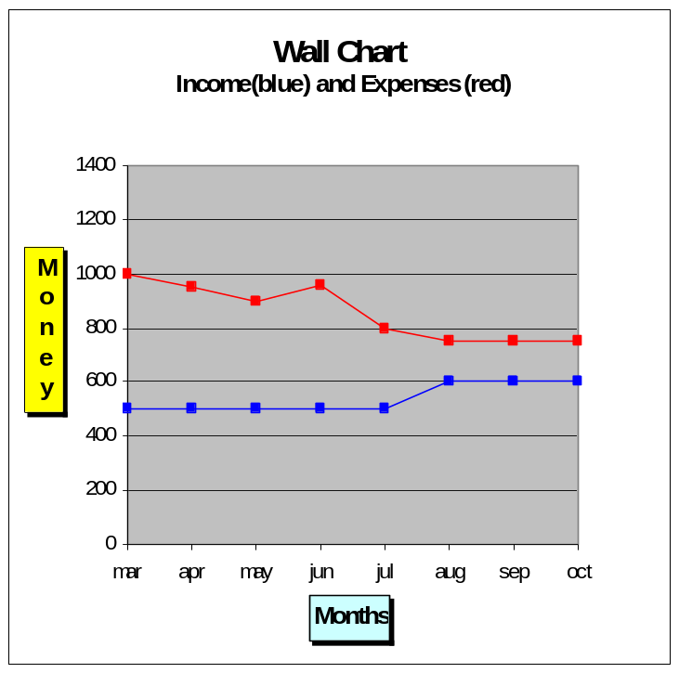
For hand-made charts get a big piece of graph paper (10 squares to the centimeter or inch is fine) that is at least 18” x 22”.
The vertical axis represents money. On the left-hand side of your chart create a scale in dollar amounts, so your first monthly income and expense figures fall in the middle of the range.
The horizontal axis represents time. Across the bottom of the chart write months/years, starting now and going through at least 5 years.

At the end of each month, enter your total monthly expenses on the chart, putting a dot by the dollar amount. Draw a line from the previous month’s mark. Plot your income in the same way, using a different color.
Post your chart so you can SEE IT EVERY DAY.
Optional: Plot your debt and saving balances in different colors, or on a separate chart, so you can see them change over time..

Step 5 How It Works
In Step 4 you began evaluating your expense categories by asking the three questions. Over time these questions will help you be increasingly aware of your spending and your level of fulfillment and alignment for each category. These questions will help you naturally modify your spending level in a way that brings maximum fulfillment and alignment. Similarly, your income level may also start to show some changes.
Your income and expenses represent hours of your life energy. In this step you will begin to see your life energy in a visual way, by plotting your monthly income and expenses on a big wall chart. In this way you can SEE a visual picture of your life energy in action, over time. As you decrease your spending, you will SEE your progress on the chart – which serves to motivate you even more.
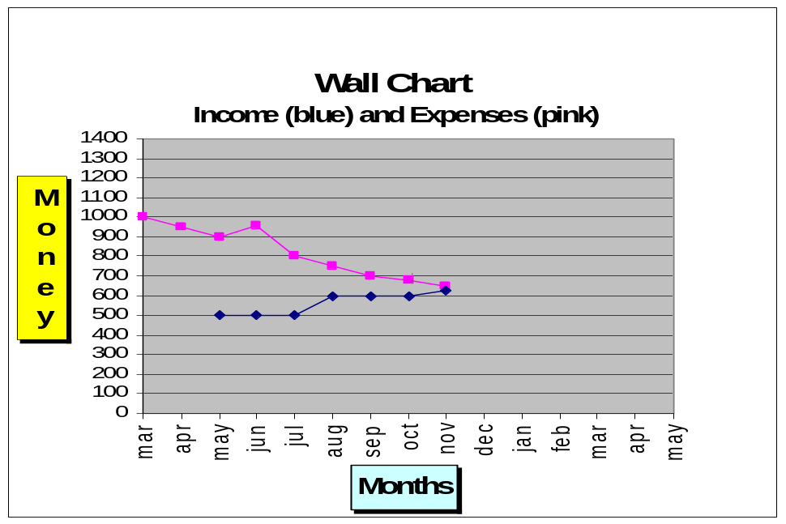
Some people choose to create their wall chart by hand. Others do it on the computer, either using spreadsheet functions or finding a personal finance program that has charting capabilities. However you create your chart, keep it in a place where you can see it every day. People who have been successful in this program maintain their wall charts for years. Why not? It’s a great reminder of what’s working for them.
A wall chart is like a map, a picture of where you’ve been and where you’re heading. You add onto this map every month as you plot your latest expenses and income. Even if you think you know where you are, it’s good to have that visual reality-check of your financial life. Real life rarely progresses in predictable increments, so the wall chart helps you to recognize the long-term trends and see progress despite individual months that may seem rocky. It can be a powerful motivator and a real reminder for celebration.
In Step 8 you will learn to use your wall chart to help you forecast your financial future.

Dealing with Debt
People who choose debt as a way of leveraging income need to realize that managing debt costs life energy and often involves a lot of risk.
For more resources and stories about dealing with debt, check the FI website.

What kinds of debt do you have? Most people carry a certain amount of debt if they have purchased a home or other major investment. These days, many people have also accumulated credit card or other consumer debt (they carry a balance from month to month).
Every dollar you pay toward debt, interest fees or other charges is a dollar that is not in savings, earning interest for you. Your goal is to pay down as much of your debt as possible so you can put those dollars to work for you instead of the lender.
Depending on the amount of debt you are carrying, you could add a debt line to your wall chart. Charting your debt balance each month can be a powerful inspiration for paying down those balances as quickly as possible.

Case Study: Chris’ Family Wall Chart
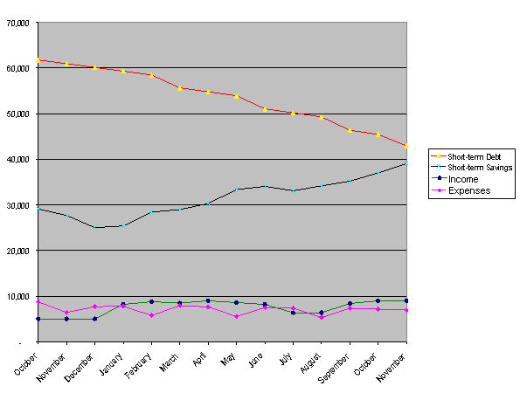
Within the first few months of plotting the family’s wall chart, it became obvious that Chris’ family expenses were usually greater than their income. Chris asked for a significant raise in December, which helped them start to live within their means. The family income is erratic though, due to Jessie’s self-employment, so the first goal the family set was to keep adding to their short-term savings, as well as paying down their large credit card balances and car loans.
Merely charting income and expenses would not have reflected that some “expenses” were really paying down debt principal. (Because any extra income was funneled into extra payments, the income and expense lines run fairly parallel). Chris plots short-term debt and short-term savings balances to help follow their true progress toward their goals – and to make sure that while paying down their debt, they don’t decrease their “rainy-day” savings.

A Gentle Reminder
This is your life! Your responsibility, in continuing to track your money, is to be very honest. If you’re spending a lot, it will show up on the wall chart. If you cut back on your gazingus pins, it will affect your expense line – for the better!
Change is difficult, and no one is perfect. You will have “good” months and “bad” months – and they will show up on the wall chart. That’s OK. Use those times to remind yourself of your purpose for doing this and your goals.
What challenges are you facing? What support do you need? Consider checking the FI website and discussion boards that are available to you. Use your creativity, intelligence and resolve to find ways to keep going. You are worth it.

Step 5 Review and Reflection
- Plotting and posting your wall chart where you will see it every day will help you focus on your overall progress toward your goals.
- How do you feel about having your financial life portrayed visibly?
- Your wall chart can be a great reminder of your progress and a motivator to keep tracking your daily expenses.
- What would you like your wall chart to look like in the future, after following this program?

Step 5 Tips for Success
- Set aside enough time each month to do your tabulation, evaluation and wall chart. This time should be something you look forward to, so build in rewards by emphasizing the step that gives you the most satisfaction.
- Create a wall chart that is visually appealing to you, using colors, gold stars or other technology/tools that you find interesting. After all, you’ll be looking at it every day.
- If looking at your chart every day becomes a source of stress, take a deep breath and take a look at it when you are doing related activities. Some keep it at work, to help them appreciate that they’re earning income; some keep it by the shopping list to remind them of their intention to make wise purchasing decisions. This is a tool for positive motivation – don’t use your chart as a bludgeon or a task-master! Remember, the important thing is maximum fulfillment.
- See the FI website to see how others have approached this step.
Step 6
Respecting Your Life Energy:
Minimizing Spending

Step 6:
Minimize Spending

Step 6 Overview
In the previous steps you redefined money in a way that made it more real in your life – as a function of your life energy, your time. You have tabulated your monthly expenses, evaluated them in terms of fulfillment and alignment and created a chart where you can visually see how they’re trending.
In this chapter you will look at ways to lower those expenses – because you respect your life energy and want to be sure you’re spending it in a way that feels good to you. And you will look at expanding your sense of personal economics to include creating long-term value for yourself and others. This chapter outlines some general principles to help you explore ways to eliminate unfulfilling spending – and also create value non-monetarily.

Step 6 Preparation
- Review your monthly tabulations and your wall chart.
- Identify categories in your monthly tabulations that are not providing satisfaction or are not in alignment with your values.
- Notice categories that might contain “gazingus pins” – those things you have a weakness for, that you just can’t help buying even though you already have plenty of them.
- Evaluate the relationship between income and expenses in your wall chart.
- How do you feel about your current real hourly wage (RHW)?
  - Not “enough”
  - OK, but could be better
  - Just the right amount
  - More than I need
- Complete the following sentence (making your best guess at the percentage): “I could still be satisfied if I were spending.…”
  - 5% less than I currently spend
  - 10% less
  - 15% less
  - 20% less
  - 25+% less
  - More than I currently spend

Step 6 Preview
Increase your consciousness around spending to decrease or eliminate the amount of life energy (money) that flows out of your life unnecessarily.
Look for ways to conserve your life energy:
- Evaluate purchases in relation to fulfillment, goals and values.
- Consciously eliminate unnecessary spending.
- Consciously reduce spending that doesn’t bring maximum fulfillment.
- Require maximum value for your money.
In other words, stop spending life energy on stuff that is not bringing you maximum fulfillment in proportion to the amount of life energy you spent on it.
Think about how much space and time that might give you to focus on living your life in alignment with your purpose, goals and values.

Benefits of Conscious Living

Builds Awareness
As you become more aware of the flow of money in your life, you will become more aware of the flow of your life energy in general. Using the tools you’ve created so far (life earnings sheet, balance sheet, tracking system, monthly tabulation with three questions, wall chart) you’re seeing more clearly the relationship between the money you spend and your personal satisfaction. Simple awareness can bring about change.

Stimulates Behavior Change
At this point in the program you may be experiencing some changes in your spending habits. In the past you may have mechanically bought things just out of habit (think of those gazingus pins), whereas now you are being more thoughtful, more deliberate, more intentional.
Consciousness
is a key component
in
achieving your goals
Through careful observation of your patterns, you are building a more conscious approach to each transaction you make. Conscious observation of your patterns results in gentle and natural shifts in behavior. Notice how different this feels from budgeting, from trying to allocate future expenses based on a standardized budget – and the sense of deprivation that often goes along with that.

Helps to Define Your “Enough”
In the past you may have thought of money as your sole security against a future where a lot could go wrong – and because future needs are unknown, you never had the sense of having enough money. Actually, true security more often comes from having the skills, ingenuity and personal relationships to find creative solutions, and spending so much of your time making money may be getting in the way of building those types of security!
Reducing your expenses results in reducing the pressure on your money earning, giving you more options and freedom.

Step 6 How It Works

Part 1: Conscious Elimination of Unnecessary Spending
Start looking at where you could eliminate or greatly reduce expenses. Ask yourself, “Are there more efficient or beneficial ways for me to spend my life energy?” Not only will this save you money, it will save you hassles and stress!

Eliminate Consumer Debt
Consumer debt is interest-bearing debt for things that won’t make you more money than they cost you (as opposed to loans to grow your business or increase the value of your house through necessary renovations). Credit-card purchases and installment payments for things that depreciate in value, like furniture, can end up costing you – not just for the items bought, but in interest, fees and all sorts of hidden or unexpected charges
Credit vs. Debt
Originally, “credit” was tied to one’s capacity to pay someone back quickly. Merchants extended credit, enabling people to buy products immediately, and expected to be repaid promptly after payday. Doing so resulted in the perception that you were “worthy of credit.”
Now, credit card companies pay the merchants immediately, but charge them a fee to do so. However, those “credit companies” make more money when you DON’T pay your balance immediately, by charging you interest and fees on the debt. The more debt you have, the more money they make. Therefore, you can now have a high credit rating (be “worthy of more credit”) and therefore get LOTS of offers, even if you DON’T have the ability to pay in the near future.
Remember that businesses that offer to “give you credit” are actually offering to “sell you debt” – and it will cost you!
Case Study: Chris’ Monthly Spending
When Chris looked at her monthly spending, she found that the interest on her consumer debt alone (credit cards and car loans) was 6% of total expenses (around $500)! She stopped using credit and started paying down her debt with the maximum amount she felt she could afford each month. Charting the falling debt balance on her wall chart was a great motivator.

Develop Maintenance Skills
By taking proper care of your possessions you can eliminate repairs that are due to neglect. Take action now to prevent minor problems from becoming major disasters later.

Case Study: Jamie’s Bike Maintenance
Jamie took a bike maintenance class to keep a beloved bike in good shape and ease the wear and tear of weekly mountain bike trips. This saved about $40 per month in maintenance and repair bills.

Case Study: Chris’ Home Maintenance
Chris enlisted her eldest son to help stain the back porch each summer (with non-toxic stain), helping to stave off a $5,000 rebuild if the boards rotted.

Eliminate Unnecessary Medical Bills
Medical bills are generally not “health-care” costs; medical care is what you feel forced to buy when you’re not healthy. In countries with private medicine, making healthy choices can eliminate some kinds of medical bills, resulting in big savings.

Case Study: Chris’ Work Enviroment
Chris realized that her high-stress, long-hours job was the source of her bursitis and carpal tunnel pain – and the resulting physical therapy bills, which were only partially covered by insurance. She had her employer bring in an ergonomic specialist to redesign her office, thereby reducing the repetitive stress issues. Eventually she decided to downshift to less-stressful work, eliminating the source of the problem altogether.

Eliminate Costly Entertainment
Often, when their personal income goes up, people engage in ever more expensive past-times to entertain themselves. Discovering the needs and desires that underlie the enjoyment can help spur creative, cheaper approaches.

Case Study: Jamie’s Love for Music
Jamie loves music and spent a lot of money on concert tickets and music recordings each month. Recognizing that new, live music was a core need, Jamie offered to write reviews for local papers and radio stations in exchange for free concert tickets. That eventually led to playing in a band and getting paid for joining in the performance!

Rent or Borrow Whenever Possible
Before you buy an item, evaluate how many times you really need to use it. Does it make sense to own it (plus maintain it, service it and store it)?

Case Study: Chris’ Home Repairs
Once they started doing their own home repairs, Chris became worried that tool purchases would take the place of maintenance fees! So Chris’ spouse, Jessie, started a neighborhood tool exchange and bought only necessary tools that were missing from the neighbors’ collections.

Eliminate Gazingus Pins
Even if you don’t want to eliminate your gazingus pins entirely, find ways to enjoy them without having to spend money on them.

Case Study: Jamie’s Music Gazingus Pin
Music recordings were Jamie’s big gazingus pin. Once Jamie started attending concerts with a press badge and/or as a performer (see “Eliminate Costly Entertainment” above), the other bands performing were usually happy to distribute a promotional copy of their music; thus the gazingus pins were attained without spending money for them!

Find Other Ways of Meeting a Need
Money was invented to purchase things that were needed or wanted and that couldn’t or wouldn’t be created by the “consumer”. What if you tried to orient your life energy toward creation rather than consumption? In the process of finding non-monetary ways to meet your needs and desires, you will build skills, relationships and confidence in your own personal resources.

Case Study: Chris’ Family Meals
Chris’ family eliminated almost half their meal costs in a way that helped establish them in their new community (you will hear about their decision to relocate later in this chapter). They joined a community garden, in cooperation with some retired former-farmer neighbors. They also shifted from weekly family restaurant meals to dinner parties, rotating the hosting duties with friends. The resulting wholesome, nearly free food and the camaraderie benefited their bodies as well as their pocketbooks, and provided the children with older mentors who had both the know-how and the time to teach them self-sufficiency skills.

Part 2: Conscious Consuming to Lower Your Spending
Conscious consuming includes understanding the value of what you are buying, beyond its current price tag. When you spend your money – your life energy – make sure you’re getting a good return on that investment.

Anticipate Needs
Be aware of what items you might need in the near future; this kind of lead time will enable you to take better advantage of sales.
Assess how much of the price of an item is due to demand: many things that have a lot of “hype” are marked up when they first go on the market, but later prices drop considerably.

Case Study: Chris’ On-Sale Toilet
One of the toilets in Chris’ house had one too many toys “accidentally” thrown down it over the years – it was on its last leg. One more fix worked, but Chris started watching the circulars for sales. She bought a low-flow toilet on sale and had it waiting in the garage for the next breakdown. No need for an emergency run to the hardware store to pay top-dollar!

Look for Quality
Do some research on the item you’re planning to buy. Is it made of strong, durable materials? Is it well crafted? How long will it last? Go to the library, the internet or “people in the know” to get recommendations on the best brands and models, and buy from companies that make quality products that last. Look at additional costs related to efficiency – will it increase your electrical, fuel or water expenses? How much will it cost to maintain? Sometimes spending more money for a high-quality item can save money in the long run.
Consider waiting for second-generation products. New models are not always tested in realistic conditions. Think about waiting until consumers have given enough feedback for the company to make improvements. Often second-generation products are also priced more moderately.

Evaluate the Value of Add-ons
Do you really need or want all the bells and whistles that come with some items? Can the more modest model meet your needs (and cost less) than the fancier one? Assess your real needs and determine the appropriate version for your situation.

Case Study: Jamie’s Replacement Mobile Phone
Jamie had a second-generation mobile phone for nine years before it finally stopped working. At that time a new gadget was being heavily marketed that included all kinds of new functions. Although it seemed like a hot item (at premium prices), Jamie noted that in the past nine years those fancy displays and functions had not seemed necessary. So was there really a need for them now? Buying a refurbished phone that was the same high-quality brand as the previous one not only kept that phone out of the waste-stream, it also saved hundreds of dollars worth of Jamie’s life energy.

The Value of Minimizing Spending
This is not about budgeting and deprivation. It’s about using your intelligence and being resourceful so as to live in alignment with your sense of fulfillment and your values. It’s your life energy you’re saving. Minimizing your spending will result in a natural and increasing tendency toward greater fulfillment and greater integrity. Spending less can feel better because it:
- lessens the pressure on earning
- frees up money and time for things that result in lasting satisfaction.

Case Study: Chris’ Re-orienting Spending According to Priorities
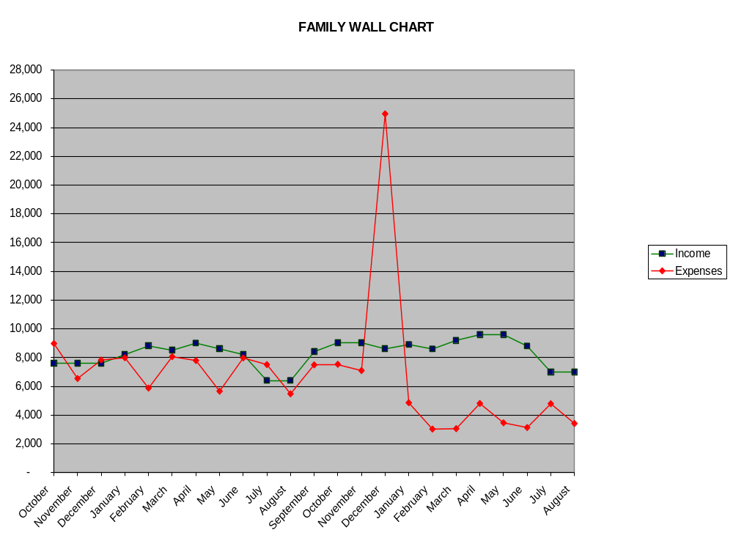
In this chart we see that Chris and her family’s expenses dropped immediately upon starting the program and then averaged out at a level that was still uncomfortably close to the amount of income that the family was generating.
So the family made a big decision that utilized several aspects of Step 6, combining both conscious spending and elimination of unnecessary spending. They decided to renovate their vacation cabin and make it their full-time home. Renovation costs account for the large spike in the expense line on their wall chart. Chris found a good (and less stressful) job in that new location, they sold their suburban home and moved to their favorite place. Although they didn’t make a profit from selling their home, this move eliminated a lot of debt and resulted in a big shift in their savings.
With less time and money spent on travel between work and two homes, their work/life balance greatly improved. This move provided the impetus to develop home-maintenance skills and build new community resources like tool and garden co-ops, resulting in even less spending. At about the same time they traded in their expensive new “career” car for a less glamorous but more gas-efficient used one, thus eliminating a car payment.
These shifts resulted in a very comfortable gap between their income line and their expense line – they were finally living within their means! They eliminated the clutter and chose fulfillment instead.

Conscious Actions
Here is a sample list of actions that can minimize or reduce spending.
Which ones could work for you?

Conscious Elimination
- Get cash when you’re at the bank or grocery store instead of at Automatic Teller Machines that charge fees.
- Make holiday presents for family and neighbors throughout the year rather than buying things with “debt cards” at the last minute.
- Cancel “Comprehensive and Collision” insurance on that dented old beater you’re still driving.
- Put enough of a down-payment on your house purchase to eliminate mortgage insurance (usually 20% of value).

Conscious Consuming
- Buy vegetables and fruits that are “in season” (or better yet, buy seeds and pots to grow them yourself on the patio!)
- Buy last year’s model or a refurbished original.
- Buy one quality item that can serve several different purposes, rather than a separate item for each purpose.

Step 6 Review and Reflection
- Minimizing spending is not about deprivation. It is about getting the most from your life energy and enjoying both greater fulfillment and increased alignment with your values and goals. Spending less can feel better because it:
  - lessens the pressure on earning money
  - frees up life energy to devote to things that bring lasting satisfaction.
- You can decrease unnecessary spending through conscious elimination of unnecessary expenses and conscious consuming.
- There are many non-monetary ways you can get your needs met and create more fulfillment.
- What categories of spending used to be automatic (like those gazingus pins) but are now decreased or eliminated? Why did you decide to change them? How did you make these changes?
- Evaluate your approach to the following and explore how you could use the principles of Step 6 to decrease expenses – and improve how you relate to these areas in the process:
  - Your home
  - Your body
  - Your community
- As you begin to practice conscious elimination of expenses and conscious consuming, notice:
  - How are you changing the attitudes and behaviors that no longer serve your purpose?
  - How are you increasing your fulfillment? In what ways is your life richer?

Step 6 Tips for Success
- Do NOT approach this like a diet, depriving yourself of what brings you joy or satisfaction. Remember, this is about respecting your life energy!
- Introduce changes at a reasonable pace that brings an ongoing feeling of accomplishment, gradually building momentum toward your goals.
- Look at your categories. Lowering your expenses will occur painlessly when you recognize the categories where you are not getting proportional fulfillment and those that are out of alignment with your purpose.
- Sometimes changing our spending habits involves taking some risks and stepping out of our comfort zone. This can be especially true in terms of interactions with others. Be patient with yourself, but do push out of your usual boxes – and be open to what you can learn in the process.
  - For example, even if you’re shy, ask a friend or neighbor who has useful home-related skills to teach you how to do some of those things (can vegetables, fix broken furniture, run diagnostics on your computer). Offer to do something for them (make them dinner, babysit) in an exchange of equal value.
  - Be willing to ask questions of sales people and manufacturers to determine whether an purchase really suits your purposes, even if it exposes your ignorance about the item or activity.
- Keep observing how these changes affect your monthly tabulation and wall chart – and how you feel about that.
- Remember that the purpose of Step 6 is still to align your personal finances with your long-term goals and values – not to be a miser! You may find that eliminating unnecessary spending can actually allow you to spend more for items that satisfy other concerns besides price, like supporting local businesses or buying from toxic-free manufacturers.
- There are many good resources with hints and tips for reducing spending. See the FI website for helpful books and organizations.

Step 7
Respecting Your Life Energy:
Maximizing Income

Step 7:
Maximize Income

Step 7 Overview
As mentioned in the previous chapter, respecting your life energy is one of the key principles of this program. While Step 6 explores how this principle applies to expenses, Step 7 applies it to income. Together these two steps orient your personal finances toward the goal of maximum fulfillment and freedom and help free you from “the rat race.”
Step 7 is about increasing your earnings, exchanging the life energy you put into your job for the highest possible income, without compromising your values or your health, for a self-defined period of time.

Step 7 Preparation
- Take some time to reflect on your current reasons for engaging in this financial program. (They may not be the same as when you started).
- Plot your latest monthly income on your wall chart (if you haven’t already).
- Estimate the hours you may have left in your life:
____ years x 8766 hours per year = ____
- Estimate the hours you may have left “on the job” until you expect to “retire”.
Example: 40 hour workweek x 52 weeks/year x 20 years = 41,600
(41,600 hours of work left until “retirement age” 20 years from now).
40 hours/week x 52 weeks/year x ____ years = _____ hours
- What is your evaluation of your current real hourly wage in relation to your income goals for that length of time?
  - Not “enough”
  - OK, but could be better
  - Just the right amount
  - More than I need, I can “retire” earlier
- What is your evaluation of the current level of effort you’re putting into your job?
  - My absolute best—total integrity and value
  - It’s a job—I just do what I have to do
  - I take as much as I can, give as little as I can

Step 7 Preview
Maximize your income, working for a self-defined period of time, while maintaining your integrity and health,.
In the following pages we will explore what this means in more detail. There are three general aspects to Step 7:
- Maximum income means earning top dollar for your time, which involves putting top effort into your employment and demanding pay equal to that effort. In addition it involves reducing job-related expenses, which increases your real hourly wage.
- Compromising your health or your values, even for a short period of time, is detrimental to achieving your goals for Financial Integrity. The means are as important as the ends.
- You define how long you pursue paid employment, based on criteria of maximum fulfillment rather than government or corporate policy.

The Purpose of Paid Employment
In Step 6 we focused on minimizing spending – reducing the flow of money out of your life. Now we’ll look at the flow of money into your life. Most people live off the income they receive from working at a job. In this chapter you will find some activities to help you better evaluate your employment income. Later in the chapter you will also consider other sources of income.
People often go to work for reasons other than simply supporting their material well-being. For many it’s not just about a paycheck; they have all sorts of emotional needs wrapped up in their jobs.
Which statement best describes your purpose for paid employment?
- For prestige, status, power and respect
- To express my creativity
- To be successful in the world
- Because of duty or public service
- For enjoyment, stimulation and learning
- Because of social or family expectations
- Because it’s my role/identity
- To interact with others, to have social connection and a sense of cooperation
- To give me a sense of purpose and contribution
- So I don’t have to stay home and take care of the kids
- To have something to do, to structure my time
- For the benefits (health insurance, life insurance, and other)
- To earn money (to pay creditors, save for the future, sustain my current lifestyle).
If you checked off reasons other than the last two on the list, consider this: You could do that for free, without getting paid for it! Any perceived benefits, other than financial, of a paying job can be obtained from non-paying activities such as volunteer work, caring for family, community activism, playing sports… the list of options is endless.

The Only Purpose of Paid Employment
This program proposes a radical notion:
There is only one purpose of paid employment: to get paid.
Does that surprise you? Reflect on your real hourly wage calculation. In terms of what you get from employment, what really “counts” has monetary value. (Even benefits like health insurance really come down to the monetary value they bring you).
This idea does not mean to devalue the work that you’re doing. Your work may be good, valuable and useful. It’s not a question of WHAT you’re doing; it’s a question of WHY you’re doing it.
Sometimes we’re attached to our jobs for emotional reasons, and that can cloud our vision. Clarifying the purpose of employment helps to bring consciousness to the realm of earning and income.

Separating Income and Work
The idea of separating money from work can be very useful. When we break that seemingly inseparable connection between our income and our work, we can look at our job and ask:
Is this really what I want to be doing with my life?
Check to see if your job supports or hinders the following areas of your life:

Area of life | Hinders | Supports
Personal relationships (family, friends, neighbors)
Personal growth (emotional, intellectual)
Health (Physical)
Inner peace (spiritual)
Contribution to society (community, planet)

Case Study: Chris’ Career
Chris decided, as a young adult, to be of service to people by working in the health-care field. She also hoped to have a family and wanted to ensure sufficient income for that, so she took a position as a public hospital administrator.
After 20 years of dedicating her life to that work, she started to notice that she spent more time doing paperwork and dealing with administrative bureaucracy than “helping sick people”.
At the same time, Chris spent much less time actually being with her family than she spent earning money for them. The stress was affecting her health, her motivation was starting to wane, and she began to feel like her performance was decreasing, even as her income slowly climbed each year.
When stress-related arm pain resulted in increasing grouchiness, both at home and at work, she realized it was time to re-evaluate her employment situation. She had to question, at age 40, whether or not she (and her family) were willing to continue in this situation for 25 more years until she reached official “retirement age.”

Step 7 How It Works
This part of the program is about creating options for yourself so that you do not HAVE to work for any longer than is needed to reach “enough.” (In Step 8 you will help define for yourself what “enough” really means).

Step 7 Actions
- Move toward the highest possible income
- Consistent with your integrity and health
- For a self-defined period of time

Let’s break Step 7 down and then see how Chris and Jamie apply it.

Part A: Move toward the Highest Possible Income
How many hours, according to your calculations, do you have left in your life? In economic terms, your time is your commodity – and it is finite. When you value your life energy, you want to maximize the benefit from any time you expend.
When you trade your time for an income,
are you getting the full value your life deserves?

How could you earn more money in your current job, while remaining in alignment with your integrity and your health? Could you move up a level or take on extra work?
Some people take a second job or increase their commitment to the current job.Some people leave their old job and move to one that maximizes their sense of engagement as well as their income, rather than staying put merely for the sake of “security.”
Most people find that when they work with a clear purpose, opportunities open up and raises are easier to negotiate. Why? Because when you know your real worth you become a more valuable employee. This helps you value yourself enough to ask for a wage that matches your effort!

Part B. Consistent with Your Health and Integrity
It does you no good to maximize your income if it costs you your health or your integrity.
If you reach the point where your job is making you sick or increasing your chances for future illness … or it is impacting your pride in your workmanship or compromising your values … it’s time to explore other options for achieving your goals.
Remember:
The point of this program is fulfillment!

In addition, sacrificing your health or your integrity even in the short term actually can decrease your ability to make money. An employee with a high rate of absenteeism, or one who cuts corners or doesn’t care about the quality of their work, will have a much harder time negotiating raises, obtaining a good reference or finding a higher paying position.

Part C. For a Self-Defined Period of Time
Suppose you look at having a job (or several jobs) as a source of income for a finite and self-defined period of time. Some people assume they will work for their rest of their lives, or at least until “retirement age” (which may seem just as long). At some point we will all stop working, whether we want to or not! When that happens is a choice we can make for ourselves. We can define that time and work towards it – giving us an even greater sense of purpose and fulfillment while we’re doing it!
Would you feel differently about your job if you knew it was for a self-defined and finite period of time? Would you …
Your job is a means to
reach your goals and
focus on what has meaning to you.

- Put in more effort?
- Work with more integrity?
- Not take setbacks or obstacles so personally?
- Give it your enthusiasm, and your appreciation?
Your job is no longer …
- Your identity
- Your prestige or status
- A paycheck that’s gone in two weeks
With this perspective you begin to more closely and consciously integrate your life energy with your work.

Case Study: Jamie’s Big Shift from Short-term to Long-term Thinking
Jamie has worked as a house painter ever since getting an after-school job in Uncle Walter’s house-building business, recognizing early on that working in the trades, while physically demanding, gave a lot of income security for someone who didn’t have a very good education. As an adult, Jamie moved to a bigger city where prevailing wages were higher and work more plentiful. Also, as we saw in Step 6, Jamie figured out some ways to actually earn money, rather than spend it, on leisure activities.
But in watching how co-workers had increasing physical difficulties as they got older, Jamie realized that a career that entailed physical labor was necessarily going to be shorter than others. It was therefore obviously important to maximize income to accommodate an earlier retirement, or to move into management. Jamie took on extra responsibilities for more pay but didn’t enjoy overseeing others, which meant that following Uncle Walter’s example would NOT be fulfilling, despite the better income.
What to do? Research revealed that union wages were significantly higher, and even off-set the extra job-related expenses of initiation fees and semi-annual membership dues. Union membership also offered more quantifiable benefits like management training and better retirement plans. Uncle Walter, Jamie’s hero and mentor, was dismayed, since he was avidly anti-union, but Jamie knew that this was the best option, in alignment with Jamie’s values and health concerns.
This is how Jamie’s wall chart looked, after making the switch:
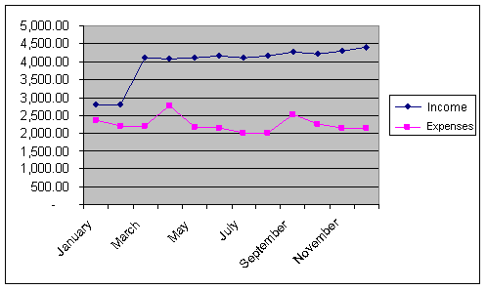

Case Study: Chris’ Career
Despite stress-related health issues, Chris’ first priority about employment was to increase income and start to make ends meet. She did some research and found that not only was her pay less than most of the colleagues in her geographical area, but the area had a lower wage than other locations. She used that knowledge to leverage a raise – but with the raise came even greater work pressure. So Chris took a big-picture look at her career and her goals. She and Jessie had already decided that they did not want to give up their beloved family vacation cabin; they had decreased their daily expenses as much as they could, but still it was not enough. What to do?
In reflecting on her real reasons for working, Chris made a long-term plan that involved compromises for a finite period of time. The family sold their big expensive suburban house and used the proceeds to make the vacation cabin into a suitable year-round residence.
Meanwhile Chris became the executive for an exclusive assisted-living facility in that high-priced vacation area. Although the switch didn’t increase nominal income much, Chris’ work was much less stressful than at the public hospital, the hours more reasonable and the commute much less, making a big difference in the real hourly wage as well as Chris’ state of mind. Although the work was less exciting, involving things like marketing, it allowed time with family to re-emerge as a primary interest.
Chris set a goal to work in that corporate management position for ten years and to use contacts there to help transition, once she reached her goals for increasing her net worth, into more hands-on work in the non-profit hospice field.
Here is what the household wall chart looked like, with the spike in expenses accounting for improvements on the cabin that became their new home:
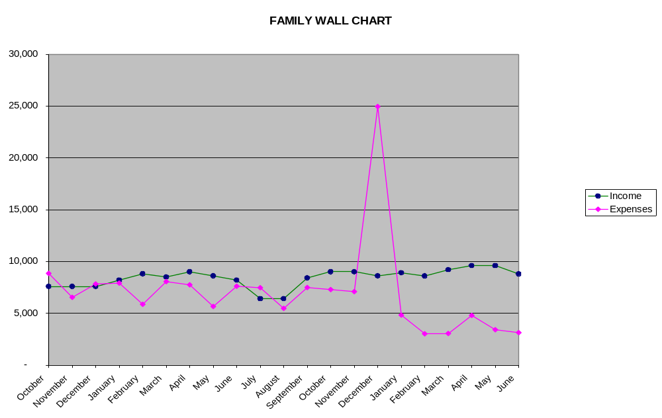

Step 7 Review and Reflection
- Maximizing your income is a way to respect your life energy. What attitudes about yourself, about your job or employer, about your ability to find a job, or about current life circumstances might be holding you back from increasing your income?
- How attached are you to your job? Is your job your identity? If you didn’t have a job, how would you describe yourself?
- If you didn’t need a paycheck, what would you be doing?
- You can choose how long you work for pay. Does knowing that paid employment is only for a finite period of time make you feel different? How?

Step 7 Tips for Success
- Make three lists of income-related goals: short-term (this month, this year), medium-term (five-ten years) and long-term (the rest of your working life). Brainstorm ways to meet those goals.
- Research things you could do to increase your real hourly wage – through both increasing income and decreasing work-related expenses.
- Review the list of your “non-tangible” assets from Step 2 and see if there are some ways you could derive income from any of those assets. For example, you throw great parties that people really enjoy; could you turn that skill into a side-line job organizing events or conventions?
Step 8
Capital and the Crossover Point

Step 8:
Capital & Crossover

Step 8 Overview
Whatever your specific goals in starting this program, the underlying intention probably had something to do with achieving clarity and ease in your relationship with money – and a sense of “enough-ness”. In Step 7 you looked at reaching enough employment and working “for a finite period of time”. Now in Step 8 you will learn how to predict just when that finite period can end; we call it the crossover point.
In Step 8 you will look at how your savings can be used as capital to earn investment income. Building on your wall chart (Step 5) you’ll project out to your crossover point, when you can meet your expenses through investment income rather than paid employment. Projecting when that date might reasonably occur is empowering because it places your current employment within the larger framework of your life.

Step 8 Preparation
- Update your wall chart, if you haven’t already.
- Keeping in mind Step 6 (minimizing expenses) and Step 7 (maximizing income), assess where you stand in terms of receiving value for your life energy:
  - I could decrease my expenses to a greater degree
  - I could increase my income to a greater degree
  - My income and expenses have currently stabilized at a point of maximum value received for my life energy.
- Envision your life without a paid job: How would you spend your time? What would be important to you? How might your answers to these questions affect your wall chart?
  - My expenses would increase (due to the lack of employer-paid benefits, due to increased travel, or the like)
  - My expenses would decrease (due to the lack of work-related expenses or greater time for do-it-yourself projects, and others)
  - I would receive income from selling assets that were no longer necessary (commuter car, “primary” home, and so on)
  - I would spend money buying new assets (musical instruments, electronics)
- What is inflation? Check all statements that are true for you:
  - A necessary and inevitable part of capitalism
  - A result of banking policies that devalue money
  - An indicator of a healthy economy
  - An economist’s statistic, manipulated for political ends
  - An economic force that I cannot control
  - A generalized number that doesn’t accurately reflect my personal experience

Step 8 Preview

Chart Your Monthly “Investment Income” and
Find Your Crossover Point

Part A: Plot Your Investment Income on Your Wall Chart
By implementing Steps 1 through 7, over time your employment income will rise above your expenses, resulting in savings. By investing that money in safe, high-yield vehicles, you will start receiving income independent of your employment income. Plot your investment income as a separate line on your wall chart. See the plotted lines in the sample chart below.

Part B: Project Your Investment Income into the Future
Project your monthly investment income into the future, based on your average rate of income each month. See the green line in the sample chart below.

Part C: Project Your Expenses into the Future
Estimate the level of spending you expect to have in the future. Keep in mind your responses to the preparation exercise, “Envision your life without a paid job.” Project your monthly expense line into the future on your wall chart. See the red line in the sample chart below.

Part D: Notice the Crossover Point
At some point your monthly investment income line will cross above the expenses line. That is your crossover point. It means you have enough money coming in to cover your normal expenses. Notice where the green line crosses over the red line in the sample chart.


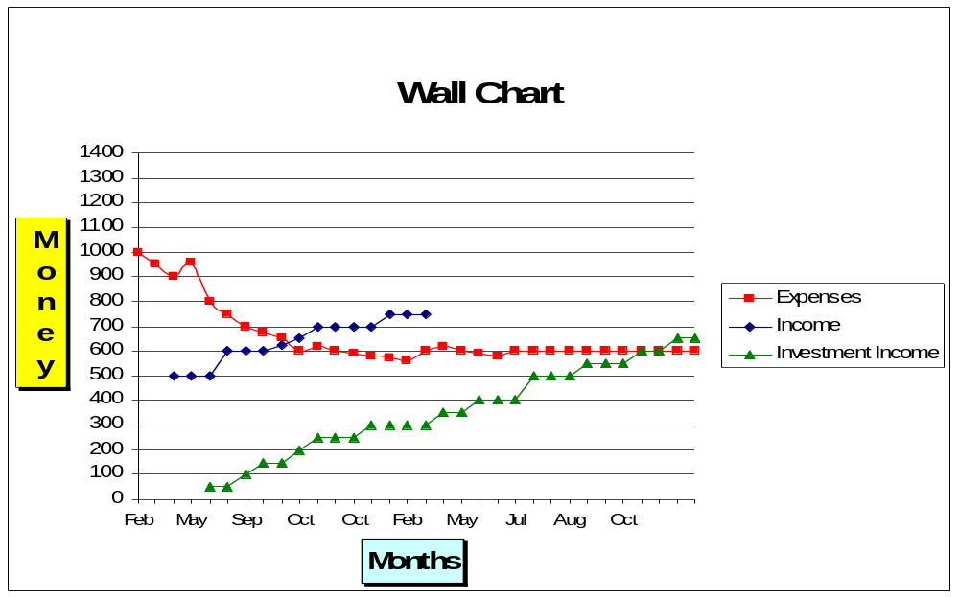
↓ projected lines ↓
Crossover Point

Capital
Currently, most of your time and life energy are probably being spent on earning income. In Step 7 we started thinking about maintaining a job for only a “finite amount of time.” Through maximizing income and minimizing expenses, an exciting thing starts to happen on your wall chart. When your expense line falls below your income line, an interesting space develops – in Chris’ chart (below) we’ve colored it yellow.

Case Study: Chris’ Wall Chart
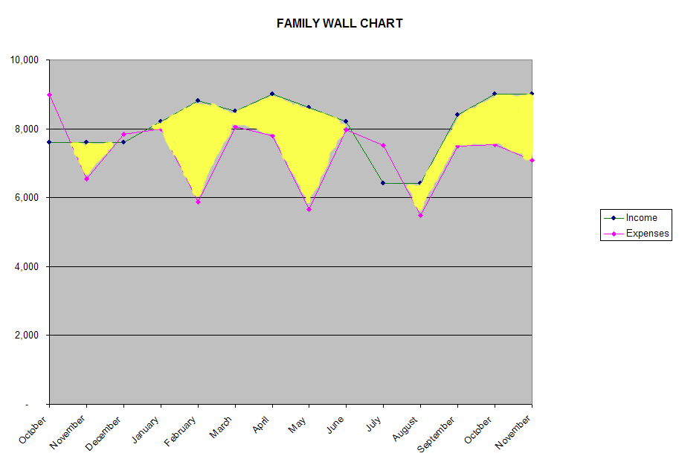
This is savings. You can also call it “capital” – because in Step 8 this money is invested to create income. When you do that you are using your money to make more money.
In Chris’ chart (above) you’ll notice that since September her employment income has remained greater than expenses and the space between the two (shown in yellow) is increasing. She is no longer accumulating debt, no longer using credit cards to cover the expenses that exceed her income – she is building savings. If she invests those savings in high-interest or dividend-bearing accounts, she will be creating investment income.

Investment Income

Capital is Money Invested to Create Income
An investment is placing your capital in some form of wealth other than cash with the expectation of deriving income. One approach is speculative investment: investing your capital in things like real estate, stocks or gold bars, with the hope that their value will rise and you can sell them later for a profit. The other approach is investing for fixed income – lending your capital to someone else and charging them a mutually agreed-upon interest rate for that use. This investment could range from a simple savings account to a bond.
Many people use bank accounts merely to store their savings for spending later, and they don’t pay much attention to earning interest. Capital, as opposed to savings, is amassed not to be spent but to be invested for a certain period of time. The whole point (for you, the investor) is what your capital earns over that period.
The income you receive from your invested capital is of a different nature than your job income. You receive it whether or not you go to work. So, on your monthly wall chart you will track that investment income separately from your other income – call it your Investment Income.

Case Study: Jamie’s Investment Income
At the age of 18 Jamie received a graduation gift from Uncle Joe in the form of a 20-year savings bond worth $20,000 and paying 6.75% interest. (Although this interest won’t be paid until year 20 when the bond “matures”, Jamie calculates the interest earned monthly). With that income, combined with the compounding interest from other investments, the yellow Independent Income line is slowly rising. Notice the jump in that line when Jamie put $15,000 from savings into a higher-yielding investment.

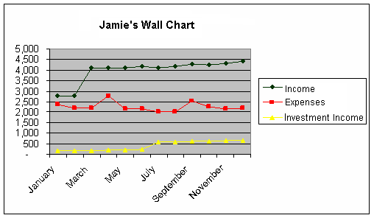

The Power of Compound Interest
When you invest your capital in an interest-bearing account, that money (your principal) earns interest. Many investments put your earned interest back into the principal, thus adding to that original amount. This new amount is a combination, or compound, of principal and interest.
Compound interest is the interest earned on the new compounded amount invested. As the original principal continues to grow in this way, so does the amount of interest you earn. It’s interest earning interest from now on.
To illustrate, below is a chart of an investment ($5,000) with compounded interest (5.5% interest rate). Note how fast the money grows over relatively short periods of time.
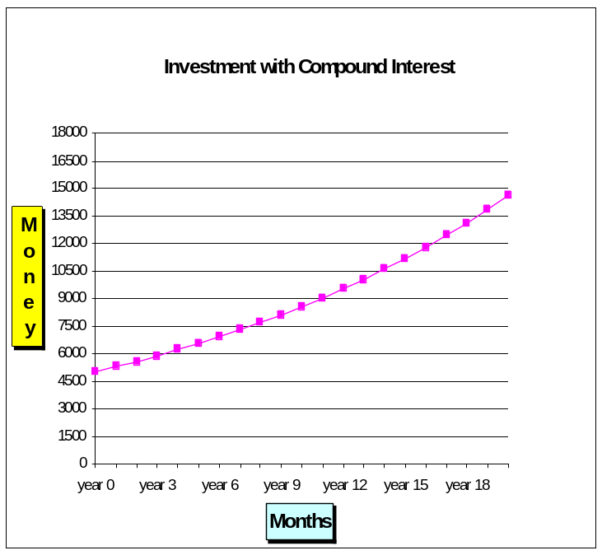
After 5 years, the principal has grown from $5,000 to $6,535.
After 10 years, it has grown from $5,000 to $8,541.
After 15 years, it has grown from $5,000 to $11,162 (more than double the original investment).

Note: if you were to keep this investment going for just another 5 years, the original investment will have almost tripled, from $5,000 to $14,589.
The sooner you invest your capital, the greater the impact of compound interest and the faster you will reach your financial goals. So, start now! (Step 9 will delve deeper into investing).

Step 8 How It Works

Part A: Plot Your Investment Income on Your Wall Chart
Plot your investment income as a separate line on your wall chart.

Part B: Project Your Investment Income into the Future
You have developed savings, have invested that money and have been receiving interest on that capital – which you have been posting on your wall chart. Now on your wall chart you can project that monthly income into the future.
With a light pencil line, project your monthly investment income into the future, based on your average rate of income each month.Part B. Project Your Investment Income into the Future
Part C: Project Your Expenses into the Future
Focus, for a moment, on the expenses line on your wall chart. As you have applied conscious spending strategies over time, this amount may have reached a comfortable level that no longer seems out of proportion with the amount of life energy it costs you; you may have determined a level of spending that is the peak of the fulfillment curve for your current life. You can now reliably estimate how much you will probably spend into the future.
Since expenses will fluctuate month to month, the determination of your monthly expense estimate going into the future is not based on the most recent month, but on the longer-term trend that you’ve been charting over time. (Refer to the FI web site for more information about the various ways people estimate their future expenses).
With a light pencil line, project the monthly expense line into the future on your wall chart.
Part D: Identify Your Crossover Point
Notice what happens with the “investment income” line: it crosses above the expenses line.
Crossover Point:
Investment Income
is
“Enough”
WOW!
This is the “crossover point” – the place where the monthly income from your invested capital exceeds your monthly expenses. At this point, you have defined “enough” and are financially independent. We often call the investment income line on your wall chart your independence income because you now have the freedom to choose whether or not you will work for money.
Plotting this on your chart will enable you to see approximately when you might attain this measure of financial independence and have enough to live at peak fulfillment without paid employment.

Case Study: Jamie’s Crossover Point
In projecting out to crossover Jamie decided to be conservative and estimate future expenses at the highest level they’d reached in the last year – and then added on a bit more each subsequent year to accommodate increases in rent and other rising costs. Income was projected to increase similarly. Factoring in an intention to transfer money from savings accounts to higher-yielding CD’s in $5,000-$10,000 amounts at modest interest rates, Jamie’s investment income line would cross the expense line by the end of the seventh year of following the program – or age 35!
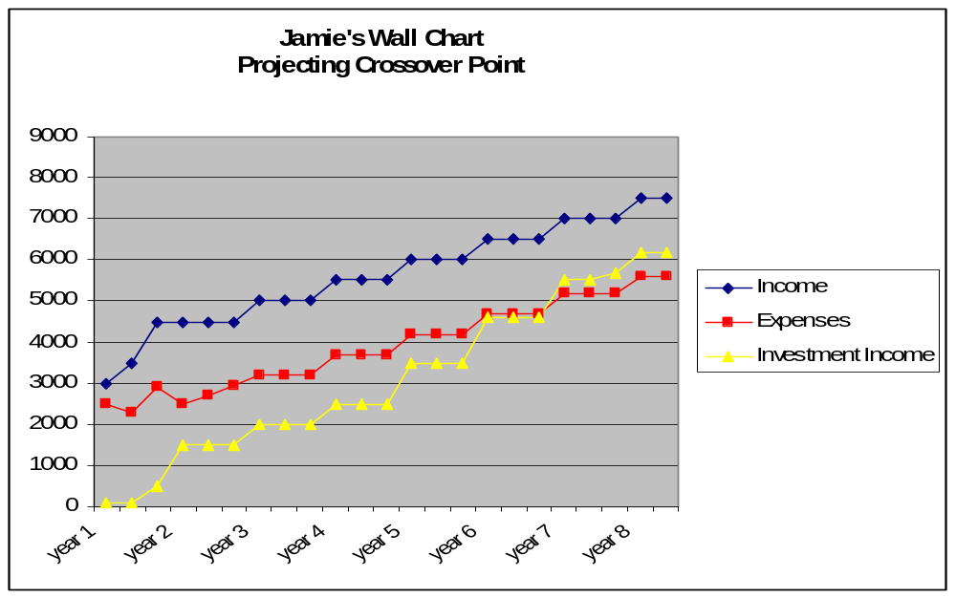

Other Factors

Average Irregular Expenses & Estimate Future Expenses
Some of your expenses will remain fairly stable from month to month, but some expense categories will be irregular – these could include tax payments, holiday or vacation spending, car repairs, dental care, and so on. It is important to remember that there will always be “unusual expenses.”
The more you can predict your expenses, regular and irregular, the better you’ll be able to predict just how much money you will need every month. Some people find it useful to average their irregular expenses over a year or more to get a sense of how those irregular categories affect the overall trends and what their future expenses might be.

Calculate Your Average over a Year
Add up a year’s worth of those irregular expenses and divide by twelve. On your monthly tabulation, enter that averaged amount each month rather than entering it in a lump sum in the month when each expense occurs. (Refer to Step 3).
Estimating future expenses involves some research and some dreaming. If you didn’t HAVE to work for a living, would you quit your job and change your daily life? How might that affect your expenses?
Some people find that expenses go down dramatically after they quit their jobs. Other people who have minimal work-related expenses actually find their expense line goes up a bit, as they spend money on activities that they didn’t have time for before. But if you continue to apply Step 6, you can reasonably estimate what your expense level might be should you choose to change your lifestyle, and your “crossover” point will adjust accordingly.

Factor in Personal Inflation
Like many other macro-economic notions, the “inflation rate” so touted in the media is a calculation that may or may not have much relevance to YOUR life. Inflation means the rate at which the “general” level of prices for goods and services is rising.
The U.S. inflation rate is generally determined by the Consumer Price Index (CPI). The CPI looks at conspicuous consumption, but how the statistic is calculated has changed dramatically over time. At the time of printing, many basic common expenses, like food and home heating or air conditioning costs are not factored in to the official inflation statistic.
It also excludes the purchases of the very rich and the very poor (or perhaps the very frugal). Samples are taken only from urban areas.
For these and many other reasons, there is a lot of debate over the usefulness of statistics like the CPI and General Inflation Rate.
The statistical inflation rate is based upon the purchases of the AVERAGE WAGE-EARNER. In other words, the average person who’s caught in the “rat race.” The question then is, how average are you?
Chances are that, after following this program, you are not average at all! By applying all nine steps you’ll provide the best possible hedge against inflation.

Calculate YOUR Inflation (or Deflation) Rate
By the time you reach your crossover point many, if not most, of your expense categories will be deflated, rather than inflated. Assuming that you’ve minimized expenses as much as you can, your expense rate should be flattening out. By the time you have tracked your expenses over a number of years, you will be able to calculate your personal rate of inflation for the spending categories you expect to continue after crossover. You’ll have data that is far more detailed and accurate for you than the government data.
- Take the spending categories from the past that apply to your life now and that you expect will apply in the future (groceries, utilities)
- Compare the current expense totals in these categories to the totals from the past
- Take that rate of change into account as you project your expenses into the future

The Wall Chart and Other Financial Goals
Your monthly tabulation (from Steps 3 and 4) helps you see your savings rate – how much your income exceeds expenses each month. The amount of money you have saved, however, is not necessarily added to your bank accounts or investments. For example, you could be using that money to pay down your debts.
The purpose of Step 8 is to motivate you to keep making progress toward a point of financial ease. You can add lines to your wall chart to gauge and celebrate your progress toward additional financial goals. Or you may want to create a separate chart for tracking debt or other financial goals.

Case Study: Smith Family Decisions
As shown in the accompanying chart, Chris’ family spent some big money remodeling their vacation home into a year-round residence, but it decreased their average monthly expenses significantly, in addition to eliminating a second mortgage. Large one-time expenses still occurred – like braces for their oldest child in June of the second year – so it was important for Chris that a certain amount of money be set aside as savings for just such unusual expenses. After that “cushion” was set aside the priority became paying off the family’s large debt, and Chris charted their progress on a separate line (in black).
As you can see, Chris’ independence income line crossed above the expense line within the second year of following the program; however, with over $20,000 left in short-term debt (not even including mortgage debt), Chris did not feel “independent” yet – but she was on her way!

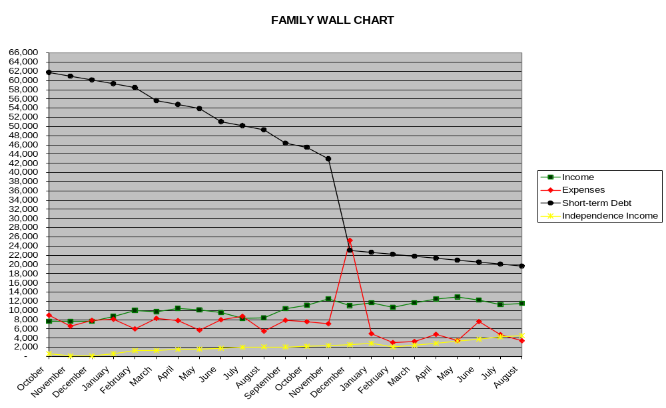

Can You Imagine a Crossover Point in Your Future?
This is when you get to turn your dreams into plans.
Planning involves taking concrete steps to create the conditions that will make your dream of financial independence become reality. Planning includes looking at what you want to do with your independence – and at what effect that might have on your expenses.
- What expenses might go up if you aren’t working and spending your time in other ways?
- What expenses might go down?
Take some time to seriously consider, in detail, what your life might look like in the future – and take this into account as you project your expense line out toward your crossover point. How long will it take to reach that crossover point? It depends on:
- How much monthly income you need
- How much capital you have to invest
- The rate of return on your investment

Finding Your “Enoughness”
Finding your “enoughness” is the key to this financial integrity program. At some point you will have defined the peak of the fulfillment curve (your enough) for yourself, based on your own experience. And now all the steps of the program come together to help you achieve your ultimate goal!
Step 1: Your personal balance sheet. If you now recalculate your fiscal net worth, you’ll find it’s not only in the red but is growing, as your interest is compounded over time and there are no liabilities dragging it down.
Steps 2 and 3: Consciousness – tracking and tabulating your money. Because you’ve become conscious of how money flows in and out of your life, you can realistically project out to your crossover point – the place of financial independence.
Steps 4 and 5: Your wall chart. Asking the three questions and plotting your income and expenses lines on your wall chart helps you live in accordance with your values AND develop the freedom to devote your time toward fulfilling your life’s goal(s). If you aren’t employed, you might find that your expense line will actually go down FURTHER as you eliminate employment-related expenses.
Step 6: Minimizing your expenses. You’ve eliminated waste and spending that takes you away from your values and goals, because you know it will actually decrease your fulfillment – and your freedom.
Step 7: Maximizing your income AND valuing your life energy. You will realize that you can quit your job, or find other work that is more personally fulfilling, or volunteer your time – and still meet the social and emotional needs that working has provided for you in the past.

Step 8 Tips for Success
- Keep your wall chart in a place where you see it regularly – but if you start to obsess about it or use it as a tool to judge yourself, look at it only when you need a reminder of your goals.
- Do update your wall chart on a monthly basis and reflect on what it’s showing you.

Step 8 Review and Reflection
- You can generate income by investing your capital in investment vehicles.
- Inflation is a generalized concept that does not necessarily define what you will experience over time. Your personal spending trends define your own inflation rate more accurately than do national inflation-rate data.
- Once you have enough predictable, dependable income from your investments, you no longer have to work for a living. You are financially independent.
- What would you do if you were truly financially independent (didn’t have to work to earn money)? Describe what financial independence would look like for you in terms of your “work” and your lifestyle. What shifts would you make in expenditures of money and time?
- How does it feel to be able to accurately estimate a date when you’ll be financially independent? How does this motivate you?

Step 9
Securing Your Financial Independence
Step 9:
Managing Your Investments

Step 9 Overview
In the previous steps we looked at building capital and reaching the crossover point – the point where your investment income meets your expenses and thus predicts your financial independence. This chapter outlines some strategies to secure that financial independence. This information will apply not only after the crossover point, but now, as you amass and invest your savings along the way to that point.
In Step 9 you will start to develop your own long-term investment program to provide sufficient income from a source other than paid employment for the foreseeable future.

Step 9 Preparation
Before you continue, ask yourself these questions:
- How long could you currently survive if you didn’t have a paying job?
- How much money do you currently have saved “for a rainy day” (not including investment capital)?
- How much money would you like to have set aside?
- If you’ve ever had someone else help you with your financial activities (a family member, a banker, a stockbroker, or financial advisor) how did you feel about their involvement?
- I had a supportive mentor teaching me.
- I had a helpmate taking care of tasks, based on my informed decisions.
- I was disempowered and had no control.
- I didn’t understand what they were doing.
- What do you think is the meaning of the term “disintermediation?”
- A grave robber’s technique
- Moving from one school level to another
- Cutting out “the middle man”

Step 9 Preview
- Develop and implement a long-term investment plan to provide secure income, for the rest of your life, from a source other than employment.
- Key characteristics of a successful plan:
  - Absolute, maximum safety of your capital (non-speculative)
  - Steady, guaranteed income (you know how much you’ll be receiving!)
  - Minimal expense of your life energy beyond self-education
  - Long-term (as in the rest of your life)

Financial Independence
So far in this program, the term financial independence has been used in a number of ways, including:
- Being free of worry and preoccupation about money.
- Feeling fulfilled whatever the level of your income.
- Having the sense of “enough”.
For the purposes of Step 9, the meaning for financial independence is more explicit. (See inset on the right).
Step 9’s Definition of
Financial Independence:
Having sufficient income, from a source other than paid employment,
to meet your needs for the rest of your life.
Since this program originated in the 1960s, most people have used the previous steps to free themselves of the burden of debt. Some people have used this program to save enough money for a few years’ sabbatical, in order to pursue opportunities they couldn’t take advantage of while working. And then there are people – like Joe Dominguez, the creator of this program – who used all nine steps to free themselves from paid employment for the rest of their lives!
The focus and intent of this chapter is not to accumulate more wealth. Step 9 assumes you’ve already started to implement the previous eight steps, and envisioned the crossover point when you will have ENOUGH. At that point it’s time to stop worrying about money and get on with whatever is really important in your life.
Anyone, from any walk of life, can achieve financial independence – and you can have that freedom WITHOUT gambling in the lottery or the stock market, WITHOUT doing anything unethical, WITHOUT speculative, high-risk real-estate investments. By making well-considered choices now, you can be free from financial worries for the foreseeable future.
It is UP TO YOU to secure that freedom, and the way to do it is to:
Become
KNOWLEDGEABLE
ADEPT
and
SOPHISTICATED
about long-term income-generating investment vehicles

Step 9 How It Works

Three Pillars of Financial Independence

CAPITAL
Money saved and invested – the income-producing basis of your investment program.
As noted in Step 8, capital is money you have saved to invest in income-producing investment vehicles. The goal of Step 9 is to SECURE that capital. At this point you have established enough income from your capital to meet your needs, so you do not need to continue growing your capital. It’s more important to make sure that your capital is always earning you a steady, predictable income to meet your needs, regardless of employment.

CUSHION
A cash reserve, earning interest in a readily accessible account, to handle emergencies, large unexpected expenses and lean times between investment income distribution.
Aim to have enough cash to cover at least six months of average expenses, as determined in Step 8. Never withdraw from your CAPITAL in order to meet your daily expenses.

CACHE
Extra money, beyond your capital and cushion, that exceeds your established needs.
Cache is a surplus of money (over and above what you have determined is ENOUGH for your needs) that accumulates for future use. It could come from increased savings based on continuing to follow Step 6 or from gifts, inheritance or other incidental income.
Since cache is not crucial to your fulfillment, you can be creative with it. You could add it to your “rainy day” cushion. You could invest in vehicles that may not meet your usual criteria for investing capital. You could be generous in your donations, gifts or endowments. This is money you can play with, without impacting your independence!

Disintermediation
The purpose of Step 9 is to empower YOU to be in control of your own financial life and to make your own decisions to secure your financial success.
A very important tenet is called DISINTERMEDIATION, or “cutting out the middle man.” This means informing yourself about investment vehicles that meet YOUR goals and values and then buying them yourself. By going directly to the source of investment to make your purchase, rather than giving your money to an intermediary (broker, financial planner, banker) who will invest your money for you (often buying the same investment instruments you could buy yourself), you will save all manner of management fees, load fees and other charges.
We cannot give you an investment recipe to blindly follow that will work for you, guaranteed, for the rest of your life. It is up to YOU to know what the best opportunities are that fit YOUR values and long-term needs.
We can, however, teach you some basics and suggest criteria you can use to create an investment program to secure financial independence as defined above.
Disintermediation means:
- Taking responsibility for being knowledgeable about how to invest your money, in accordance with your goals and values.
- Taking responsibility for purchasing and managing those investments yourself, rather than going through an intermediary.

Your Investment Criteria
Be empowered to decide for yourself! You can choose how to weigh the various investment criteria listed below. Make your choices according to your values, current investment options, and your willingness to go back to paid employment if things don’t turn out as you project. The suggested criteria on the following page are for people who don’t want to worry about income for the foreseeable future of their lives. It’s definitely not a quick way to make money, and it’s not going to vastly increase your wealth. If you have followed through on the previous steps you have achieved “ENOUGHNESS” and now the most important thing is to be free!
Free to get off the work treadmill. Free from monetary concerns. Free to choose how you want to live.
Nothing in life is guaranteed, but applying these criteria strictly and continuing to practice financial integrity for the rest of your life will create the surest likelihood that you never have to work again.
Remember, Step 9 is simply to become knowledgeable, adept and sophisticated about long-term, steady income-generating investment vehicles
WHY long-term? You’re now thinking in terms of the whole of your life and how to ensure sufficient income for the foreseeable future. By putting your money in long-term investments, you can expect a higher rate of return and you can lock in that rate for a longer period of time.
WHY steady income? You know how much income you need to live with maximum fulfillment, so you need investments that will guarantee that amount – and guarantee that the income will come in steadily so that you can be assured of covering your expenses.
WHY knowledgeable, adept, and sophisticated? You don’t have to become knowledgeable about ALL types of investments, just the ones that meet your criteria. The financial world is constantly changing, with new investment options showing up all the time. But an investment, like any other purchase, is an exchange you make with your life energy – and people are going to try and sell you something with their benefit in mind. Luckily, you’ve learned how to become adept, knowledgeable and sophisticated about financial decisions, thanks to the previous eight steps. Now apply the skills learned in the previous steps to your investments with Step 9.
- Do your research and consider the long-term impact of your decisions.
- Minimize expenses (money and time) and look for long-term value.
- Maximize income – within your prudent criteria.
- Apply your values and goals to your decision-making.
- Stay open and aware of new opportunities for growth and learning.

Suggested Investment Criteria

Safety | Your capital MUST be protected. Speculative investments like stocks can make your capital disappear overnight and send you back to job-hunting. Safety of capital and income is a must.  Yes, safe investments generally have lower returns than speculative ones. In this program, however, we approach investments NOT to grow income, but to ENSURE income for the long term. You don’t want to worry about losing your savings – the capital that creates that income – so safety is absolutely required.
Guaranteed Stable Income | The rate of return must be established at the time of investment so that you know exactly what your income will be on an ongoing basis (and so you know you will be able to cover your expenses!) The income should be paid at regular intervals. And it should be available now, not at some retirement age specified by an outside authority.
Liquidity | You must be able to convert your capital into cash-in-hand at any moment (and without losing a substantial amount to penalties) to handle emergencies that exceed your cushion.
Minimized Costs (Money) | You don’t want to have your capital or income diminished substantially by management fees or other investment charges. Beware hidden fees and penalties, and be sure to research tax implications of the various investment vehicles.
Minimized Costs (Life Energy) | The whole point is to be freed from having a job, so don’t choose investment vehicles that bring you the “job” of having to maintain, watch and manage them.
Long-Term | Financial markets change continually. In order to secure your income for as far into the future as possible, pick vehicles that lock in a rate of return for the longest term possible. These are called fixed income investments. If, later on you discover long-term investments that are better than what you currently hold, you can always shift investments, assuming you’ve followed the previous liquidity criteria.

Step 9 Tips for Success
- Research investment vehicles for high yield and high safety. There are many resources available, both online and in periodicals, to help you do this. Watch out for fees, or penalties for accessing your money whenever you need to, which may cancel out any interest earned. Read the fine print!
- Many people who follow this program “ladder” their fixed-income investments by buying in batches with varied maturity dates. Laddering means that if one of your investments is “called” (if an institution pays back your capital and recalls the bond or other investment vehicle) you still have other investments that continue to pay income while you take the time to reinvest that capital.
- You can create “pockets” of money with differently weighted criteria. For example, you can prioritize liquidity for your cushion, prioritize security for your capital, and prioritize maximum returns (with more risk) for any cache you create and want to invest.
- See the FI website for more resources on investing from a financial integrity perspective.

Step 9 Review and Reflection
- Financial independence is having sufficient income, from a source other than paid employment, to meet your needs for the rest of your life. Anyone from any walk of life can achieve financial independence. (See the FI web site to find real-life examples).
- Did you consider financial independence a possibility when you started the program? Do you feel any differently about that as a goal now?
- In terms of the financial integrity program, the foundation of financial independence is investing your capital in secure, long-term investments. Financial independence can happen when that stable investment income is at a level that will meet your projected expenses for the foreseeable future. How is this different from the messages you hear about “retirement”?
- Disintermediation (“cutting out the middle man”) means taking responsibility for purchasing and managing your own investments. How do you feel about the idea of being responsible for your own investment decisions?
- What do you think will be the hardest part of this program for you to maintain? How might you meet that challenge?
Congratulations!

Congratulations!
You have now learned all the basics to achieving Financial Integrity!
The 9 Steps are skills and principles that can serve you for the rest of your life. They are like the steps in a recipe, or parts of a DNA spiral – the building blocks of a fulfilling life. What grows out of them is up to you. You can get out of debt, align your financial actions with your inner aspirations, and achieve financial independence – but even more subtle and profound changes are possible.
Just as all the spokes of a wheel are important to moving forward smoothly, so it is with the steps. When you give equal weight to ALL the steps, you can go to amazing places very quickly. And when you discover how well they work for you, you will continue implementing them – over and over again.

Independence and Inter-Dependence
At this point, people begin to fantasize about what’s going to happen when they pass the Crossover Point and are financially independent.
Like a prisoner released after many years in jail, many people who’ve reached financial independence have found it can take a few years to transition to the reality of that freedom. Others stay in the “rat race” out of worry about unforeseen events that may bring them back below the crossover point of financial freedom.
Many people have asked if there isn’t a secret “Step 10” addressing the deeper transformations that start once they are free of financial pre-occupations! Well, there isn’t a Step 10, because what you need to know is contained within the Nine Steps, but perhaps a little more subtly than is apparent at first reading.
Remember the first part of the “Fulfillment Curve – Survival”?
When someone is struggling to create food and shelter, the work can be all-consuming. It’s hard to think about the needs of others or take a longer view when our personal needs are so urgent. Many people carry that sense of pressure much farther up the curve, and it can be hard to let it go even after reaching the peak of “enoughness”. Other people fear the freedom of financial independence will just lead to boredom or a laziness that will undermine their sense of self-worth.
Yet, there are adventures beyond the occupation of getting and spending that can be even more fulfilling. In fact, that was the whole point for program originator Joe Dominguez.
After you’ve reached ENOUGH, and you are at the peak of the curve in terms of money spent, you can still increase your fulfillment.

Participation
When we have met our personal needs and wants, what is there left to do?
Well, we can expand our focus. We can go from “getting and spending” to “giving, receiving, and participating” in a larger circle of concern, expanding the mindfulness of the nine-step approach into other aspects of how we live.
We can put more energy toward contributing to the needs and comforts of family members and friends, our community, our nation, our world.
Merely by living a joyful, free life and having the time to share it, we can inspire others to live a life of financial – and personal – integrity and fulfillment!

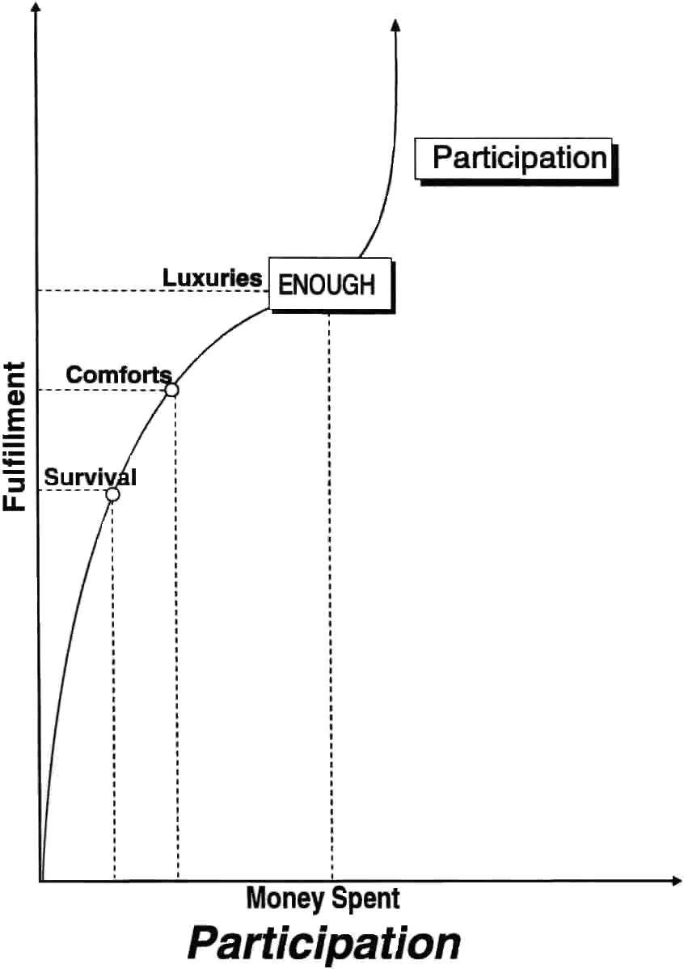
Joyful participation and service can expose us to new perspectives, expand our skill set, introduce us to new friends, strengthen our relationships, and give our life greater meaning than we ever knew before. Such personal expansion will serve us no matter what life throws our way.

Maintaining Financial Integrity
The late Joe Dominguez, upon hearing that someone attained financial independence through his method, would send them a kind letter with a real government bond in congratulations… only the bond was issued by the Czarist Russian Government of 1916 (just before the Bolshevik revolution) and was consequently worthless!
It was his way of slyly saying, “Congratulations, but don’t get complacent.” Nothing is guaranteed in this world, so stay conscious, stay creative, and stay engaged – even when you think you’ve reached “the peak.”
Continuing to follow the steps in this program will not only keep integrity in your finances, but will also help you remember the real purpose of money, and that the exchanges we create are not just monetary.
The rewards of life come whenever the flow of our life energy creates fulfillment for yourself and others.
Keeping these principles in mind will help you to live productively for the rest of your life.

